**MINISTRY OF EDUCATION AND TRAINING**

**FPT UNIVERSITY**

Capstone Project Report 4

**Building the bids online system**

|  |  |
| --- | --- |
| **Group 10** | |
| **Group members** | Huỳnh Tịnh - SE62713  Nguyễn Huy Hoàng - SE61758  Phạm Hoàng Phúc Nguyên - SE62075  Hà Trung Kiên - SE61993 |
| **Supervisor** | Hồ Hoàn Kiếm |
| **Ext. Supervisor** | N/A |
| **Capstone Project Code** | eBOS |

- Ho Chi Minh City, 14 September 2018 -

# Table of Contents

Table of Contents 2

List of Tables 4

List of Figures 4

Software Design Description 7

1. Design Overview 7

2. System Architectural Design 7

3. Component Diagram 9

4. Details Description 10

4.1. Class Diagram 10

4.2. Class Diagram Explanation 11

4.2.1. User 11

4.2.2. Admin 12

4.2.3. Personal member 12

4.2.4. Role 12

4.2.5. UserRole 12

4.2.6. Address 13

4.2.7. Item 13

4.2.8. Auction 13

4.2.9. Category 14

4.2.10. Media 14

4.2.11. Bid 14

4.2.12. MinIncrementRule 15

4.3. Interactive Diagram 15

4.3.1. Guest 15

4.3.1.1. Login 15

4.3.1.2. Register account 15

4.3.1.3. Search Auctions 16

4.3.1.4. View Auction Details 16

4.3.1.5. View Suggested Auctions 17

4.3.2. Administrator 17

4.3.2.1. Accept Auction 17

4.3.2.2. Reject Auction 18

4.3.2.3. Search Users 18

4.3.2.1. Activate User 19

4.3.2.2. Restrict User 19

4.3.3. Auctioneer 20

4.3.3.1. Submit Auction 20

4.3.4. Bidder 21

4.3.4.1. Place Bid 21

4.3.5. Auctioneer & Bidder 21

4.3.5.1. View Auction History 21

4.3.5.2. Register address 22

4.3.5.3. View Contact Information 22

4.4. State Machine Diagram 23

5. User Interface Design 24

5.1. Web admin application user interface 24

5.1.1. Login 24

5.1.2. View Dashboard 25

5.1.3. View User Management Page 26

5.1.4. View Pending Auctions 27

5.1.5. View List Auctions 28

5.1. Web application user interface 29

5.1.1. Login/Register 29

5.1.2. Nav Bar 32

5.1.3. Home Page - List of auctions 32

5.1.4. Submit Auction 34

5.1.5. Search auctions by category 35

5.1.6. Bidding History 38

5.1.7. Selling History 40

5.1.8. Auction Details 42

5.1.9. Search By Keyword Result 45

5.1.10. Register address 46

5.2. Mobile application user interface 47

5.2.1. Opening Page 47

5.2.2. Login page 48

5.2.3. Update Address 49

5.2.4. Register Account page 50

5.2.5. Home page 51

5.2.6. Auction Detailss Page 52

5.2.7. Personal page 53

5.2.8. Bidding History page 55

5.2.9. Selling History page 56

5.2.10. Submit Auction page 56

5.2.11. Category page 58

5.2.12. Item By Category page 59

5.2.13. Search page 60

6. Database Design 62

6.1. Entity relationship diagram (ERD) 62

6.2. Entity dictionary 62

7. Algorithms 64

7.1. Automatic bidding 64

7.1.1. Definition 64

7.1.2. Define problem 64

7.1.3. Solution 64

7.1.4. Complexity 65

7.1.5. Example 65

7.2. Auction’s Time Remaining Consistency Among Clients 65

7.2.1. Define problem 65

7.2.2. Solution 65

7.2.3. Complexity 65

7.3. Auction suggestion based on the one that user is currently viewing 65

7.3.1. Define problem 65

7.3.2. Solution 65

7.3.3. Complexity 65

7.3.4. Example 65

# List of Tables

Table 1 - Component Dictionary 10

Table 2 - Class Dictionary 11

Table 3 - Class Diagram Explanation <User> 11

Table 4 - Class Diagram Explanation <Admin> 12

Table 5 - Class Diagram Explanation <Personal member> 12

Table 6 - Class Diagram Explanation <Role> 12

Table 7 - Class Diagram Explanation <UserRole> 12

Table 8 - Class Diagram Explanation <Address> 13

Table 9 - Class Diagram Explanation <Item> 13

Table 10 - Class Diagram Explanation <Auction> 14

Table 11 - Class Diagram Explanation <Media> 14

Table 12 - Class Diagram Explanation <Bid> 14

Table 13 - Class Diagram Explanation <MinIncrementRule> 15

Table 14 - Entity dictionary 63

Table 15 - Bid Incremement 64

Table 16 - Example table for viewing history 65

Table 17 - Example table for affinity score 66

# List of Figures

Figure 1 - System Architecture Design 7

Figure 2 - Component Diagram 9

Figure 3 - Class Diagram 10

Figure 4 - Sequence Diagram for Login < Guest > 15

Figure 5 - Sequence Diagram for Register Account < Guest > 16

Figure 6 - Sequence Diagram for Search Auctions < Guest > 16

Figure 7 - Sequence Diagram for View Auction Details < Guest > 17

Figure 8 - Sequence Diagram for View Suggested Auctions < Guest > 17

Figure 9 - Sequence Diagram for Accept Auction < Administrator > 18

Figure 10 - Sequence Diagram for Reject Auction < Administrator > 18

Figure 11 - Sequence Diagram for Search Users < Administrator > 19

Figure 12 - Sequence Diagram for Activate User < Administrator > 19

Figure 13 - Sequence Diagram for Restrict User < Administrator > 20

Figure 14 - Sequence Diagram for Submit Auction < Auctioneer > 20

Figure 15 - Sequence Diagram for Place Bid < Bidder > 21

Figure 16 - Sequence Diagram for View Auction History < Auctioneer/Bidder > 22

Figure 17 - Sequence Diagram for Register Address < Auctioneer/Bidder > 22

Figure 18 - Sequence Diagram for View Contact Information` < Auctioneer/Bidder > 23

Figure 19 - State Machine Diagram of Auction 23

Figure 20 - Admin Web Interface <Login> 24

Figure 21 - Admin Web Interface <View Dashboard> 25

Figure 22 - Admin Web Interface <View User Management Page> 26

Figure 23 - Admin Web Interface <View Pending Auctions> 27

Figure 24 - Admin Web Interface <View List Auctions> 28

Figure 25 - Web Interface <Login/Register/Search> 29

Figure 26 - Web Interface <Login Popup> 29

Figure 27 - Web Interface <Register account> 31

Figure 28 - Web Interface <Menu bar and Categories> 32

Figure 29 - Web Interface <Home page - Newly listed auctions> 32

Figure 30 - Web Interface <Home page - Ending soon auctions> 33

Figure 31 - Web Interface <Home page - Highest number of bids > 33

Figure 32 - Web Interface <Home page - Recently viewed auctions > 34

Figure 33 - Web Interface <Submit Auction> 34

Figure 34 - Web Interface <Dropdown list of categories> 36

Figure 35 - Web Interface <Auctions By Category> 36

Figure 36 - Web Interface < Categories bar and sort> 37

Figure 37 - Web Interface <Bidding Auctions History> 38

Figure 38 - Web Interface <Won Auctions History> 38

Figure 39 - Web Interface <Lost Auctions History> 39

Figure 40 - Web Interface <Contact Seller> 39

Figure 41 - Web Interface <Active Auctions History> 40

Figure 42 - Web Interface <Ended Auctions History> 40

Figure 43 - Web Interface <Rejected Auctions History> 40

Figure 44 - Web Interface <Pending Auctions History> 41

Figure 45 - Web Interface <Contact Bidder> 41

Figure 46 - Web Interface <Auction Details> 42

Figure 47 - Web Interface <Confirm to place bid> 43

Figure 48 - Web Interface <Bidding History> 44

Figure 49 - Web Interface <Recommended Auctions> 44

Figure 50 - Web Interface <Search By Keyword Result> 45

Figure 51 - Web Interface <Register address> 46

Figure 52 - Mobile Interface <Opening> 47

Figure 53 - Mobile Interface <Login> 48

Figure 54 - Mobile Interface < Update address> 49

Figure 55 - Mobile Interface <Register account> 50

Figure 56 - Mobile Interface <Home> 51

Figure 57 - Mobile Interface <Auction Details> 52

Figure 58 - Mobile Interface <Personal> 53

Figure 59 - Mobile Interface <Selling> interface 54

Figure 60 - Mobile Interface <Bidding History> 55

Figure 61 - Mobile Interface <Auction Submit> 56

Figure 62 - Mobile Interface <Choose image> 57

Figure 63 - Mobile Interface <Category> 58

Figure 64 - Mobile Interface <Item by category> 59

Figure 65 - Mobile Interface <Search> 60

Figure 66 - Mobile Interface <Search result> 61

Figure 67 - Entity relationship diagram (ERD) 62

# **Software Design Description**

## **Design Overview**

This document describes the technical and user interface design of Bidding Online System (eBOS). It includes the architectural design, the detailed design of common functions and business functions and the design of database model.

The architectural design describes the overall architecture of the system and the architecture of each main component and subsystem.

The detailsed design describes static and dynamic structure for each component and functions. It includes class diagrams, class explanations and sequence diagrams for each use cases.

The database design describes the relationships between entities and detailss of each entity.

Document overview:

Section 2: gives an overall description of the system architecture design.

Section 3: gives component diagrams that describe the connection and integration of the system.

Section 4: gives the details design description which includes class diagram, class explanation, and sequence diagram to detailss the application functions.

Section 5: describes screens design.

Section 6: describes a fully attributed ERD.

Section 7: describes algorithms.

## **System Architectural Design**

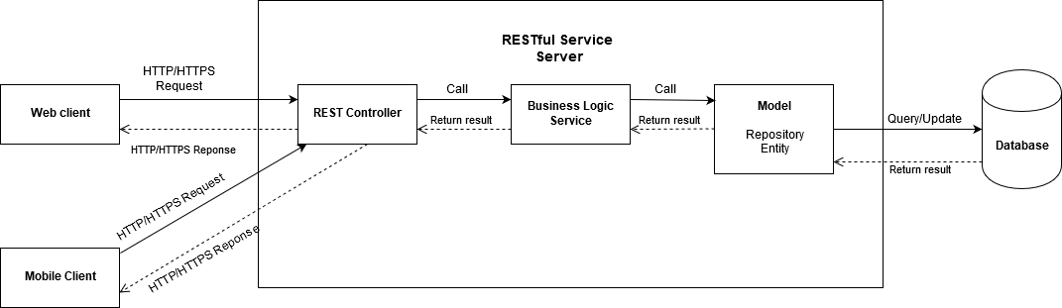

Figure 1 - System Architecture Design

Our system has been developed under the REST architectural style. The web application and mobile application will access allowed resources provide by RESTful web services.

We choose this architecture for our system because of following advantages:

* Minimize the coupling between client and server components, we can update the server regularly without needing to update the client application or vice versa.
* Build only one place providing web services for both web client and mobile client. The client only needs to know URLs and other information for fetching/updating desired resources and communicate to server through HTTP/HTTPS protocol.
* Define clearly set of permissions for accessing resources. Not every resources that client can access from the web services, they need to provide information for server to authenticate and authorize it to access which resources.
* Testing each component in the architecture become more convenient.
* Faster development process (rapid and parallel development): One programmer can work on mobile application or web application without affecting to another one working on web services.

The system consists of the following components:

* RESTful Service Server: provides RESTful web services for client to access data and resources. It also authenticates and authorizes client so that client can gain permissions for desired resources. It includes the following sub-components:
  + REST Controller: declares mapping request URL for receiving and handling appropriate HTTP/HTTPS requests sent from client. Basically, it calls appropriate Business Logic Services to process the request’s information and receives processed data from them, finally responds a HTTP/HTTPS including data to the client.
  + Business Logic Service: implements heavily system’s business logic, receives request’s information from REST Controller, processes it then calls appropriate JPA repositories to write/read data to/from database and return result back to the controller.
  + Model: provides data from database and supports data query, creation, update to database. It includes repositories and entities. Repositories supports reading/writing transactions for data from database, and also supports pagination and sorting which makes development process more convenient. Entities model objects in the system that having relevance to the database, and store information about those objects.
* Mobile client: provides system’s functions for user on a mobile application running on his/her own smartphone. It displays UI, sends user’s input under HTTP/HTTPS request to server, and later receives HTTP/HTTPS response from server and render result into view and display it on the screen.
* Web client: provides system’s functions for user on a web application running on web browser. It displays UI, sends user’s input under HTTP/HTTPS request to server, and later receives HTTP/HTTPS response from server and render result into view and display it on the web page.
* Database: organizes, stores collection of data from system.

## **Component Diagram**

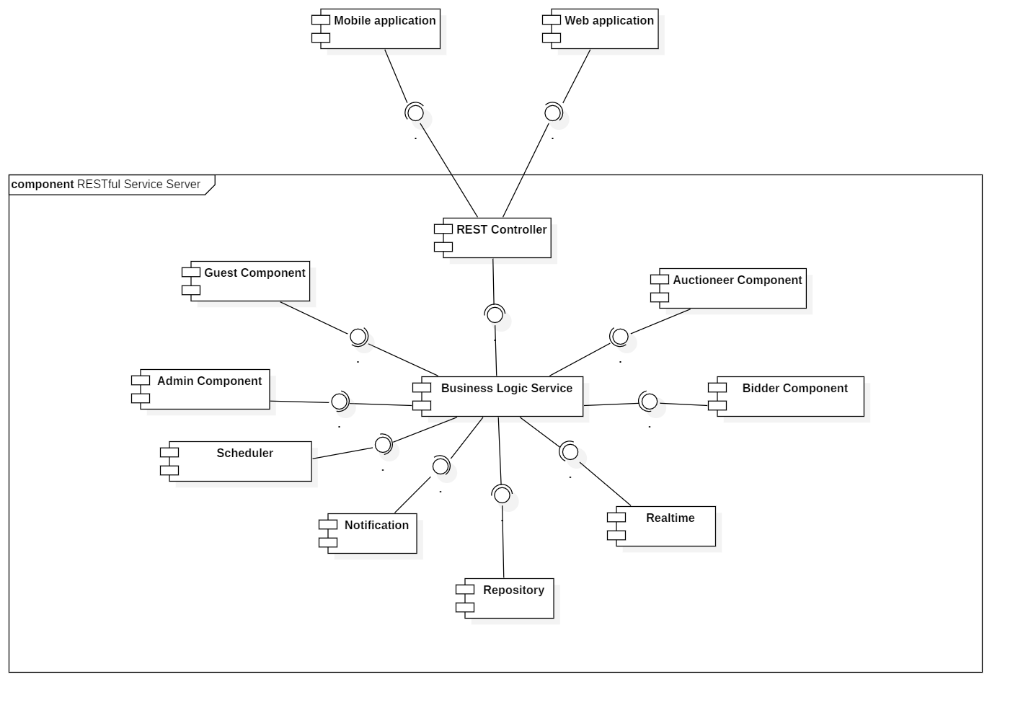

Figure 2 - Component Diagram

|  |  |
| --- | --- |
| COMPONENT DICTIONARY: DESCRIBES COMPONENTS | |
| Mobile Application | Component to contain system’s functions for end user on mobile device |
| Web Application | Component to contain system’s functions for end user on web |
| REST Controller | Component to receive requests, call services to process information, get data back from services and respond result to clients |
| Business Logic Service | Component to handle system’s business operations |
| Guest Component | Component to handle guest’s activities in the system |
| Admin Component | Component to handle admin’s activities in the system |
| Bidder Component | Component to handle bidder’s activities in the system |
| Auctioneer Component | Component to handle auctioneer’s activities in the system |
| Scheduler | Component to handle scheduling future tasks |
| Realtime | Component to handle realtime operations |
| Notification | Component to handle sending notifications |
| Repository Component | Component to handle data reading/writing operations from/to database |

Table 1 - Component Dictionary

## **Details Description**

### Class Diagram

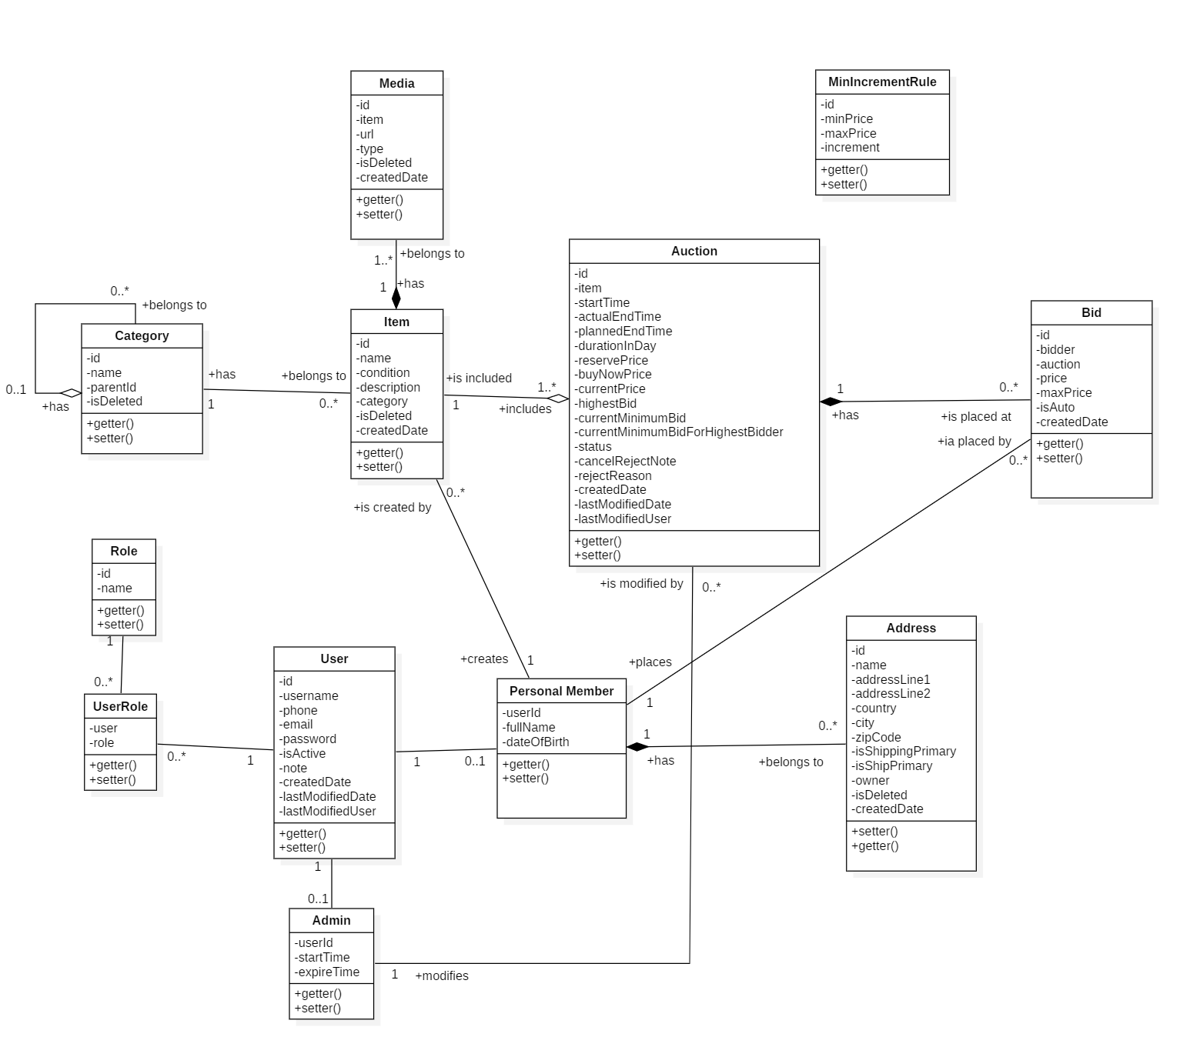

Figure 3 - Class Diagram

|  |  |  |
| --- | --- | --- |
| CLASS DICTIONARY: DESCRIBE CLASS | | |
| Class Name | **Mapping column with Conceptual diagram** | **Description** |
| User | User | Contains the user information |
| Admin | Admin | Contains the admin information |
| Personal Member | Auctioneer/Bidder | Contains the personal member (auctioneer, bidder) information |
| Role | Role | Contains the role information |
| UserRole | N/A | Contain the user’s roles information |
| Address | Address | Contain the address roles information |
| Item | Item | Contains the item information |
| Auction | Auction | Contains the auction information |
| Category | Category | Contains the category information |
| Media | Media | Contains the media information |
| Bid | Bid | Contains the bid information |
| MinIncrementRule | N/A | Contains the minimum increment rule information (for calculating minimum bid that bidder has to place on an item). |

Table 2 - Class Dictionary

### Class Diagram Explanation

#### User

|  |  |  |  |
| --- | --- | --- | --- |
| **Attribute** | **Type** | **Visibility** | **Description** |
| id | Integer | Private | Unique identifier of a user |
| username | String | Private | User’s username |
| password | String | Private | User’s password |
| phone | String | Private | User’s phone |
| email | String | Private | User’s email |
| status | String | Private | User’s status |
| note | String | Ptivate | User’s note (reason for being restricted) |
| createdDate | ZonedDateTime | Private | User’s created date |
| lastModifiedDate | ZonedDateTime | Private | User’s last modified date |
| lastModifiedUser | User | Private | User who modified lastly this one |
| **Method** | **Return Type** | **Visibility** | **Description** |
| getter | Attribute type | Public | Get value of attribute |
| setter | Void | Public | Set value for attribute |

Table 3 - Class Diagram Explanation <User>

#### Admin

|  |  |  |  |
| --- | --- | --- | --- |
| **Attribute** | **Type** | **Visibility** | **Description** |
| userId | Integer | Private | Unique identifier of an admin (from that of his/her user account) |
| startTime | ZonedDateTime | Private | Admin’s start time for performing operations |
| expireTime | ZonedDateTime | Private | Admin’s expire time for performing operations |
| **Method** | **Return Type** | **Visibility** | **Description** |
| getter | Attribute type | Public | Get value of attribute |
| setter | Void | Public | Set value for attribute |

Table 4 - Class Diagram Explanation <Admin>

#### Personal member

|  |  |  |  |
| --- | --- | --- | --- |
| **Attribute** | **Type** | **Visibility** | **Description** |
| userId | Integer | Private | Unique identifier of a personal member (from that of his/her user account) |
| fullName | String | Private | Personal member’s full name |
| dateOfBirth | ZonedDateTime | Private | Personal member’s date of birth |
| **Method** | **Return Type** | **Visibility** | **Description** |
| getter | Attribute type | Public | Get value of attribute |
| setter | Void | Public | Set value for attribute |

Table 5 - Class Diagram Explanation <Personal member>

#### Role

|  |  |  |  |
| --- | --- | --- | --- |
| **Attribute** | **Type** | **Visibility** | **Description** |
| id | Integer | Private | Unique identifier of a role |
| name | String | Private | Role’s name |
| **Method** | **Return Type** | **Visibility** | **Description** |
| getter | Attribute type | Public | Get value of attribute |
| setter | Void | Public | Set value for attribute |

Table 6 - Class Diagram Explanation <Role>

#### UserRole

|  |  |  |  |
| --- | --- | --- | --- |
| **Attribute** | **Type** | **Visibility** | **Description** |
| user | User | Private | User who is assigned to the role |
| role | Role | Private | Role which is assigned to the user |
| **Method** | **Return Type** | **Visibility** | **Description** |
| getter | Attribute type | Public | Get value of attribute |
| setter | Void | Public | Set value for attribute |

Table 7 - Class Diagram Explanation <UserRole>

#### Address

|  |  |  |  |
| --- | --- | --- | --- |
| **Attribute** | **Type** | **Visibility** | **Description** |
| id | Integer | Private | Unique identifier of an address |
| name | String | Private | Address’s name |
| addressLine1 | String | Private | Address’s addressline1 (Street name, town, ward, etc) |
| addressLine2 | String | Private | Address’s addressline2 (floor number, apartment number, etc) |
| country | String | Private | Address’s country |
| zipCode | String | Private | Address’s ZIP code or portal code |
| isShippingPrimary | String | Private | Is address is default for shipping address or not (receiving item) |
| isShipPrimary | String | Private | Is address is default for ship address or not (sending item) |
| owner | User | Private | Address’s owner |
| isDeleted | Boolean | Private | Address is deleted or not |
| createdDate | ZonedDateTime | Private | Address’s created date |
| **Method** | **Return Type** | **Visibility** | **Description** |
| getter | Attribute type | Public | Get value of attribute |
| setter | Void | Public | Set value for attribute |

Table 8 - Class Diagram Explanation <Address>

#### Item

|  |  |  |  |
| --- | --- | --- | --- |
| **Attribute** | **Type** | **Visibility** | **Description** |
| id | Integer | Private | Unique identifier of an item |
| name | String | Private | Item’s name |
| condition | String | Private | Item’s condition |
| category | Category | Private | Item’s category |
| isDeleted | Boolean | Private | Item is deleted or not |
| createdDate | ZonedDateTime | Private | Item’s created date |
| **Method** | **Return Type** | **Visibility** | **Description** |
| getter | Attribute type | Public | Get value of attribute |
| setter | Void | Public | Set value for attribute |

Table 9 - Class Diagram Explanation <Item>

#### Auction

|  |  |  |  |
| --- | --- | --- | --- |
| **Attribute** | **Type** | **Visibility** | **Description** |
| id | Integer | Private | Unique identifier of an item |
| item | Item | Private | Auction’s item |
| startTime | ZonedDateTime | Private | Auction’s start time |
| actualEndTime | ZonedDateTime | Private | Auction’s actual end time |
| durationInDays | ZonedDateTime | Private | Auction’s duration in days |
| plannedEndTime | ZonedDateTime | Private | Auction’s planned end time |
| reservePrice | BigDecimal | Private | Auction’s reserve price |
| buyNowPrice | BigDecimal | Private | Auction’s buy now price |
| currentPrice | BigDecimal | Private | Auction’s current price |
| highestBid | Bid | Private | Auction’s highest bid |
| currentMinimumBid | BigDecimal | Private | Auction’s current minimum bid |
| currentMinimumBid  ForHighestBidder | BigDecimal | Private | Auction’s current minimum bid for highest bidder |
| status | String | Private | Auction’s status |
| note | String | Private | Auction’s note for being rejected by admin |
| rejectReason | String | Private | Auction’s reason for being rejected by admin |
| createdDate | ZonedDateTime | Private | Auction’s created date |
| lastModifiedDate | ZonedDateTime | Private | Auction’s last modified date |
| lastModifiedUser | User | Private | User who modified lastly this auction |
| **Method** | **Return Type** | **Visibility** | **Description** |
| getter | Attribute type | Public | Get value of attribute |
| setter | Void | Public | Set value for attribute |

Table 10 - Class Diagram Explanation <Auction>

#### Category

|  |  |  |  |
| --- | --- | --- | --- |
| **Attribute** | **Type** | **Visibility** | **Description** |
| id | Integer | Private | Unique identifier of category |
| name | String | Private | Category’s name |
| parentId | Integer | Private | Unique identifier of category’s parent |
| isDeleted | Boolean | Private | Category is deleted or not |
| **Method** | **Return Type** | **Visibility** | **Description** |
| getter | Attribute type | Public | Get value of attribute |
| setter | Void | Public | Set value for attribute |

Table 11 - Class Diagram Explanation <Category>

#### Media

|  |  |  |  |
| --- | --- | --- | --- |
| **Attribute** | **Type** | **Visibility** | **Description** |
| id | Integer | Private | Unique identifier of media |
| item | Item | Private | Media’s Item |
| url | String | Private | Media’s URL |
| type | String | Private | Media’s type |
| isDeleted | Boolean | Private | Media is deleted or not |
| createdDate | ZonedDateTime | Private | Media’s created date |
| **Method** | **Return Type** | **Visibility** | **Description** |
| getter | Attribute type | Public | Get value of attribute |
| setter | Void | Public | Set value for attribute |

Table 11 - Class Diagram Explanation <Media>

#### Bid

|  |  |  |  |
| --- | --- | --- | --- |
| **Attribute** | **Type** | **Visibility** | **Description** |
| id | Integer | Private | Unique identifier of bid |
| bidder | User | Private | Bid’s bidder |
| auction | Auction | Private | Bid’s auction |
| price | BigDecimal | Private | Bid’s price |
| maxPrice | BigDecimal | Private | Bid’s maxPrice |
| isAuto | Boolean | Private | Bid is placed by automatic bidding system or not |
| createdDate | ZonedDateTime | Private | Bid’s created date |
| **Method** | **Return Type** | **Visibility** | **Description** |
| getter | Attribute type | Public | Get value of attribute |
| setter | Void | Public | Set value for attribute |

Table 12 - Class Diagram Explanation <Bid>

#### MinIncrementRule

|  |  |  |  |
| --- | --- | --- | --- |
| **Attribute** | **Type** | **Visibility** | **Description** |
| id | Integer | Private | Unique identifier of rule |
| minPrice | BigDecimal | Private | Rule’s minimum price |
| maxPrice | BigDecimal | Private | Rule’s maximum price |
| increment | BigDecimal | Private | Rule’s increment |
| **Method** | **Return Type** | **Visibility** | **Description** |
| getter | Attribute type | Public | Get value of attribute |
| setter | Void | Public | Set value for attribute |

Table 13 - Class Diagram Explanation <MinIncrementRule>

### Interactive Diagram

#### Guest

##### Login

Summary: this diagram shows process for login.

x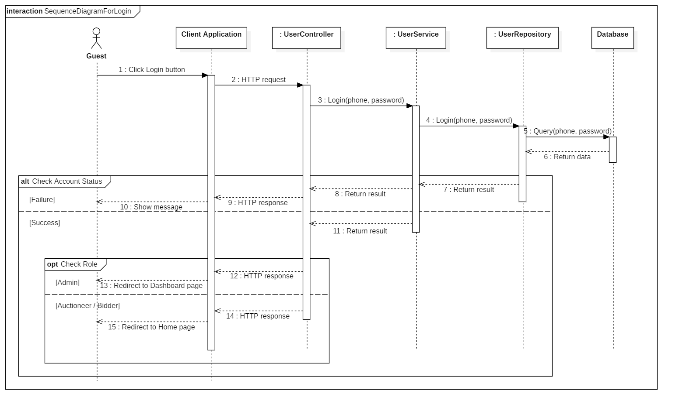

Figure 4 - Sequence Diagram for Login < Guest >

##### Register account

Summary: this diagram shows process for register account.

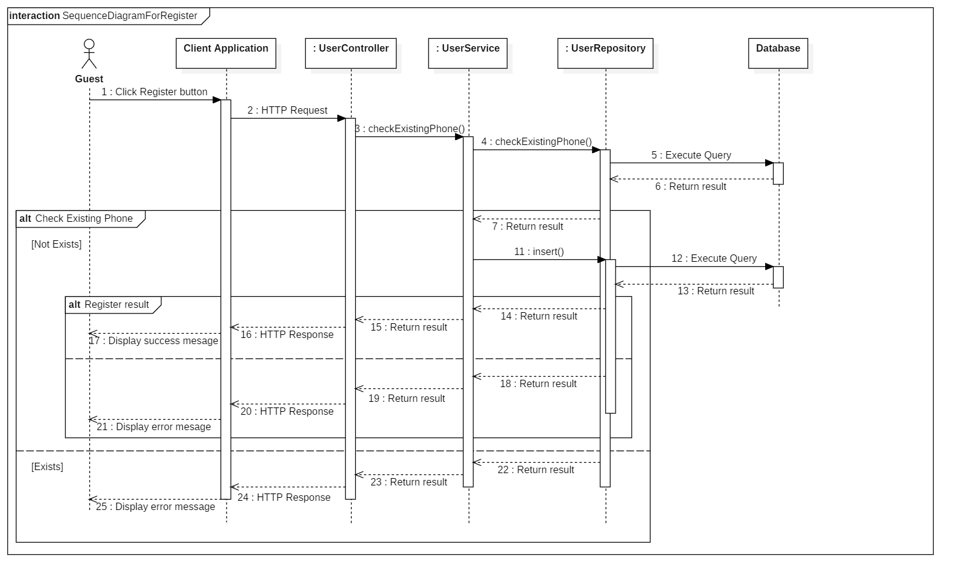

Figure 5 - Sequence Diagram for Register Account < Guest >

##### Search Auctions

Summary: this diagram shows process for search auctions (by keyword/ category).

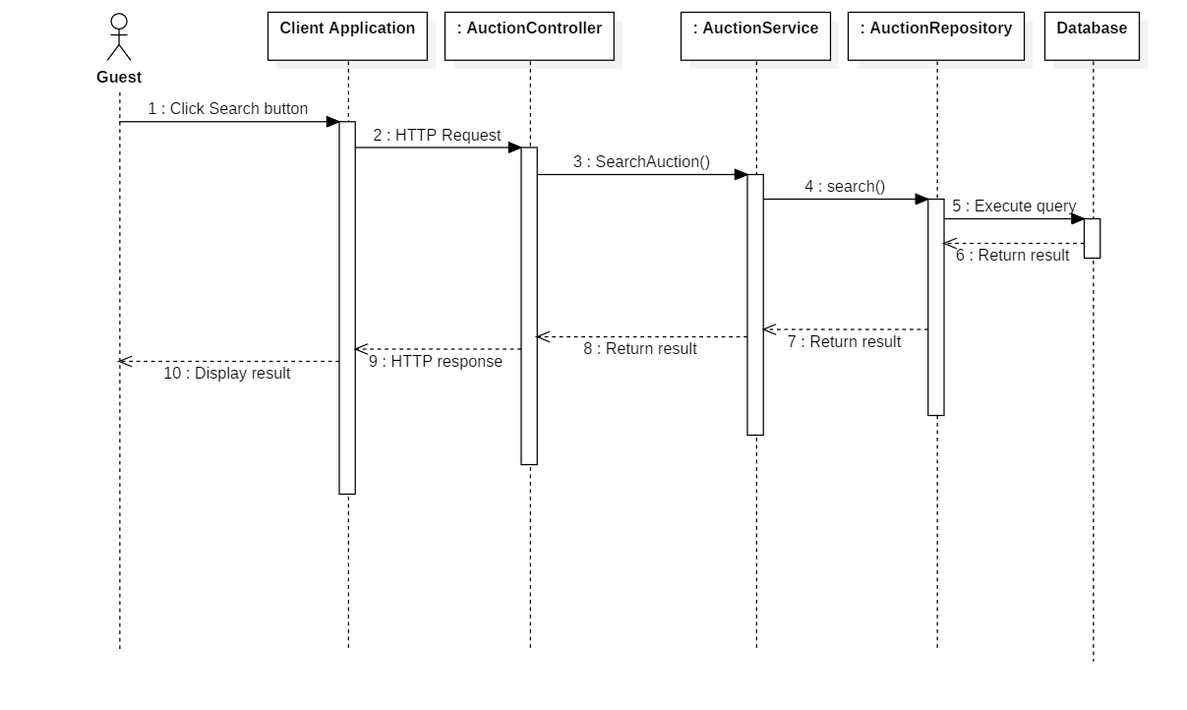

Figure 6 - Sequence Diagram for Search Auctions < Guest >

##### View Auction Details

Summary: this diagram shows process for view auction details.

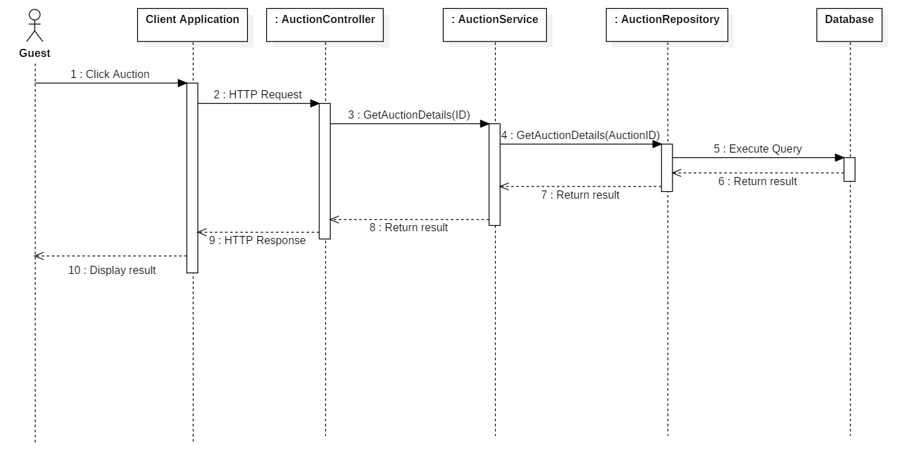

Figure 7 - Sequence Diagram for View Auction Details < Guest >

##### View Suggested Auctions

Summary: this diagram shows process for view suggested auctions

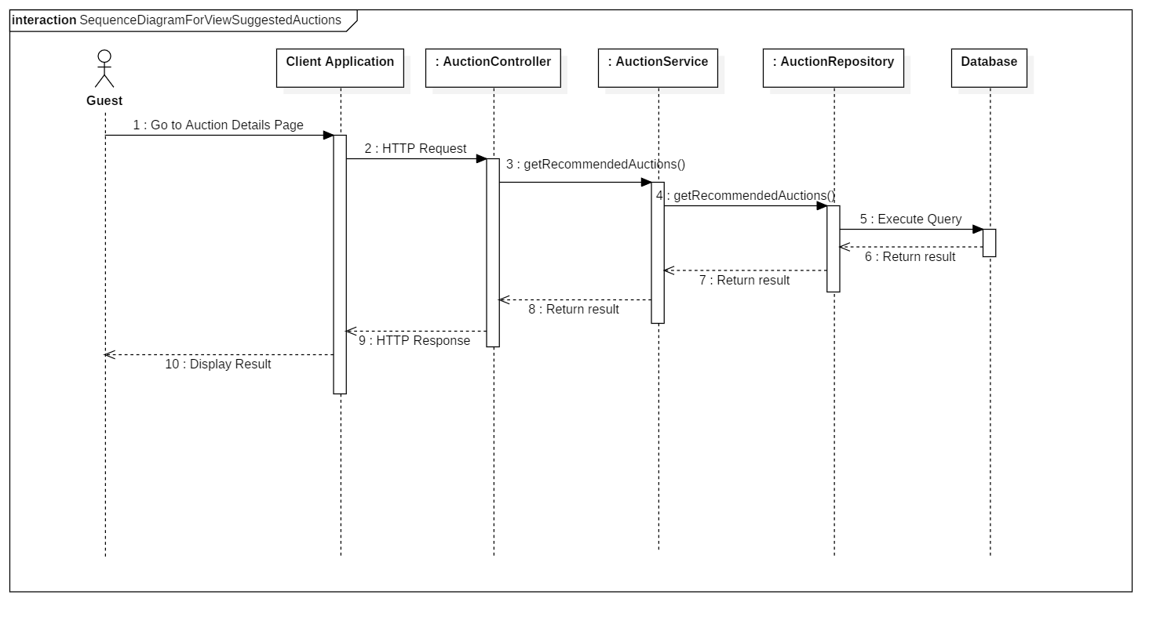

Figure 8 - Sequence Diagram for View Suggested Auctions < Guest >

#### Administrator

##### Accept Auction

Summary: this diagram shows process for accept auction.

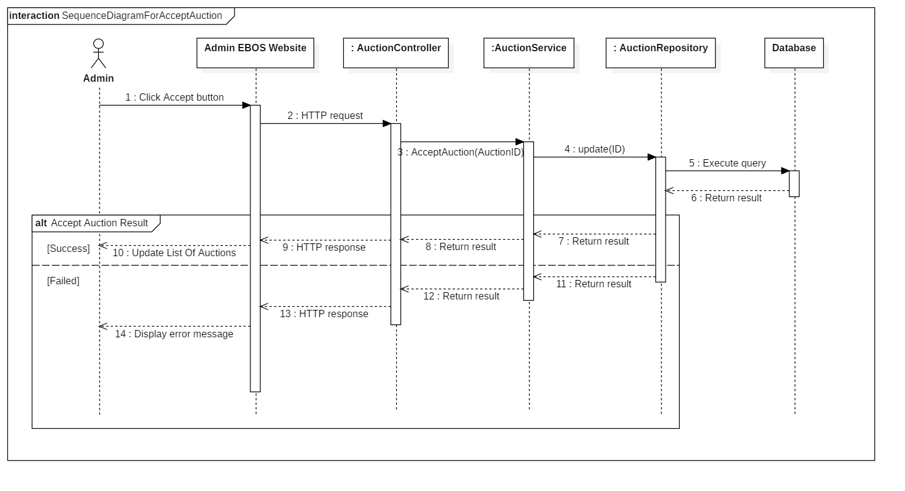

Figure 9 - Sequence Diagram for Accept Auction < Administrator >

##### Reject Auction

Summary: this diagram shows process for reject auction.

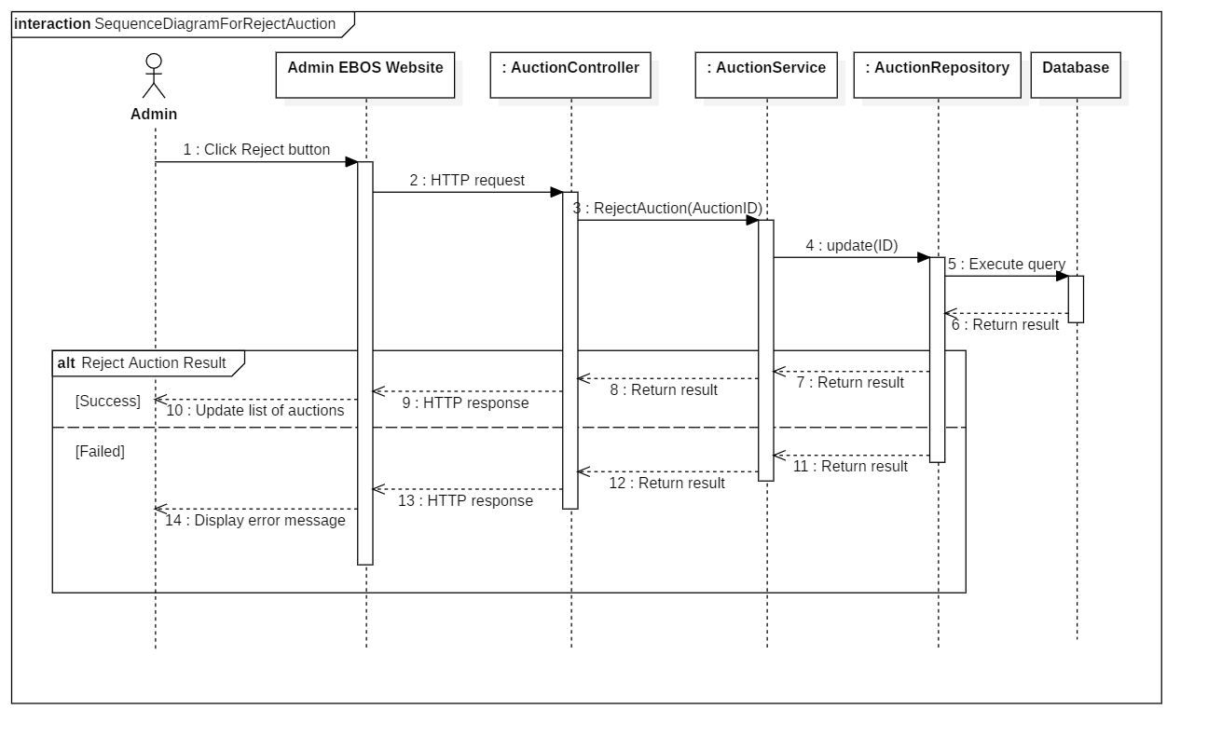

Figure 10 - Sequence Diagram for Reject Auction < Administrator >

##### Search Users

Summary: this diagram shows process for search users.

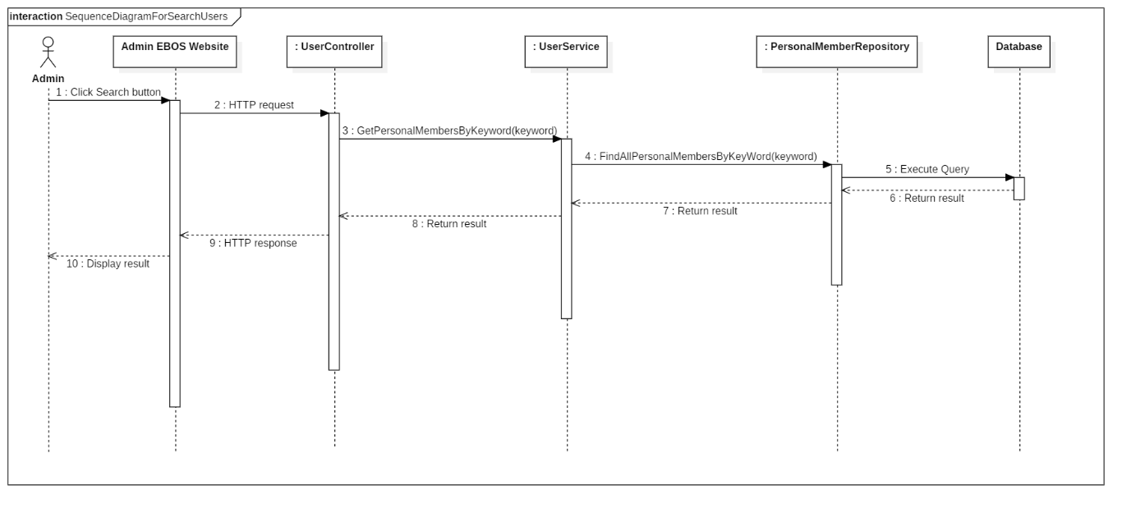

Figure 11 - Sequence Diagram for Search Users < Administrator >

##### Activate User

Summary: this diagram shows process for activate user.

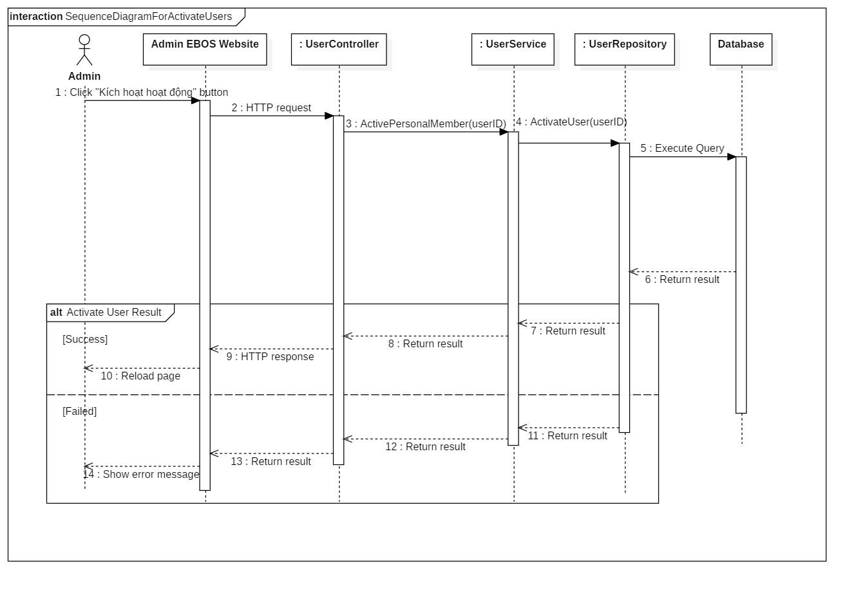

Figure 12 - Sequence Diagram for Activate User < Administrator >

##### Restrict User

Summary: this diagram shows process for restrict user.

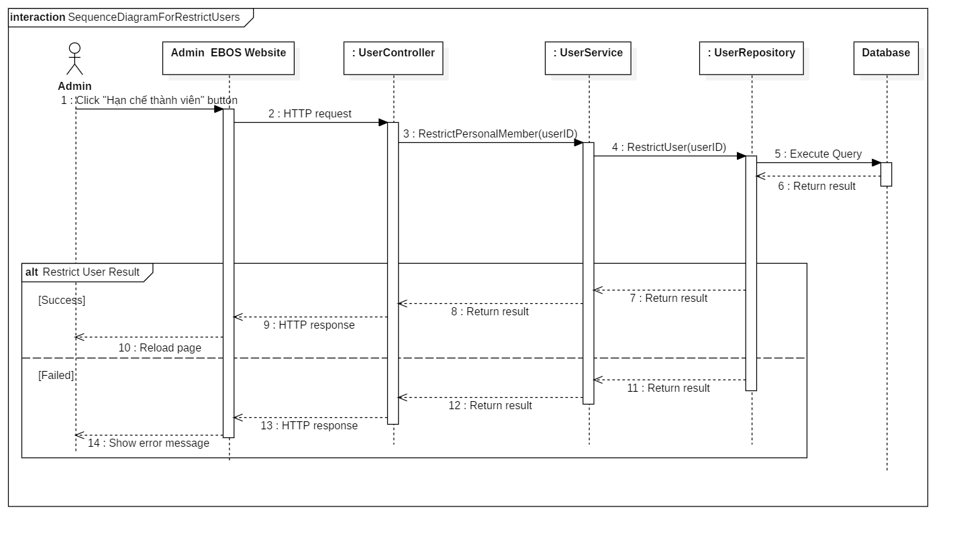

Figure 13 - Sequence Diagram for Restrict User < Administrator >

#### Auctioneer

##### Submit Auction

Summary: this diagram shows process for submit auction.

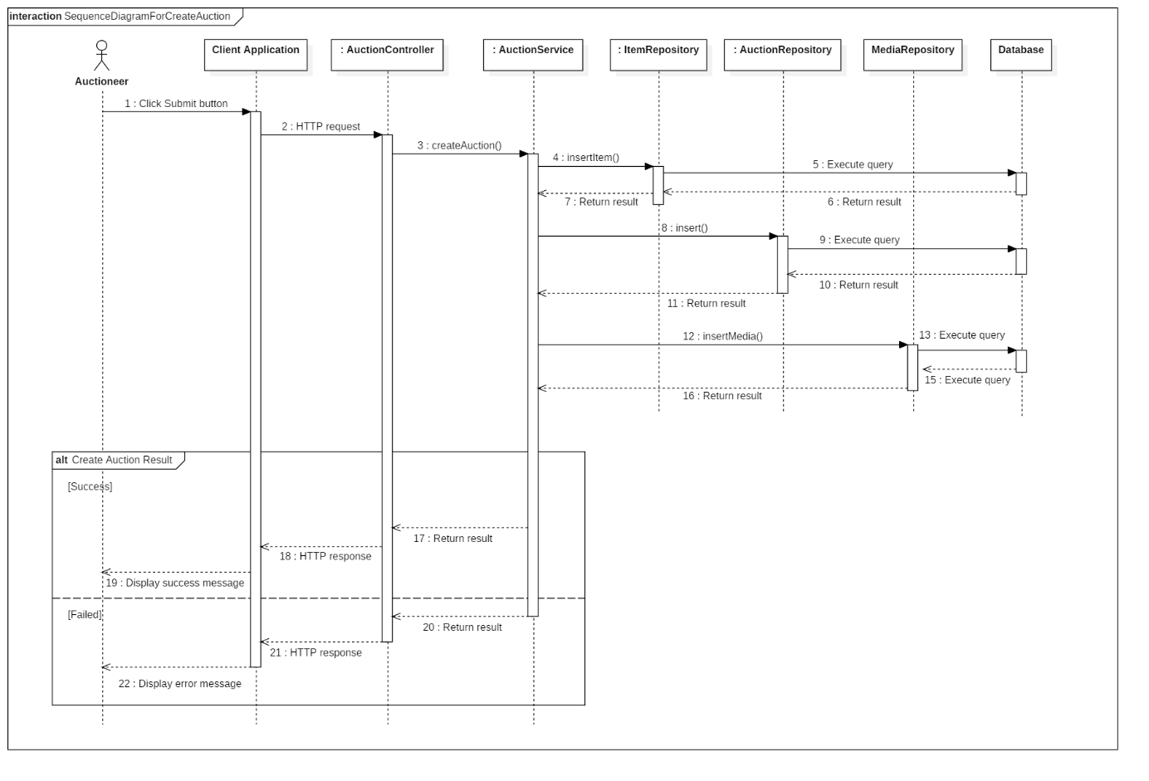

Figure 14 - Sequence Diagram for Submit Auction < Auctioneer >

#### Bidder

##### Place Bid

Summary: this diagram shows process for place bid.

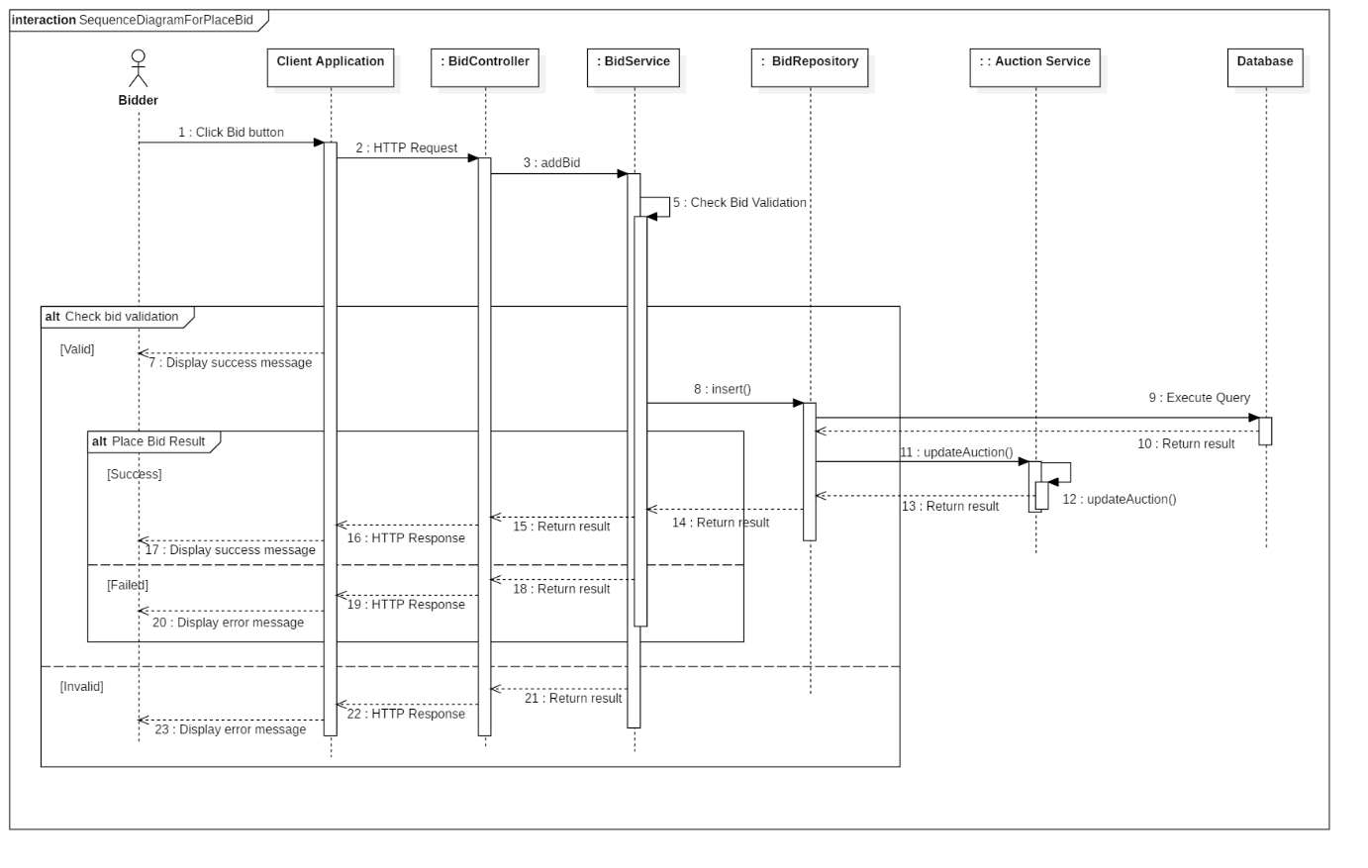

Figure 15 - Sequence Diagram for Place Bid < Bidder >

#### Auctioneer & Bidder

##### View Auction History

Summary: this diagram shows process for view auction history.

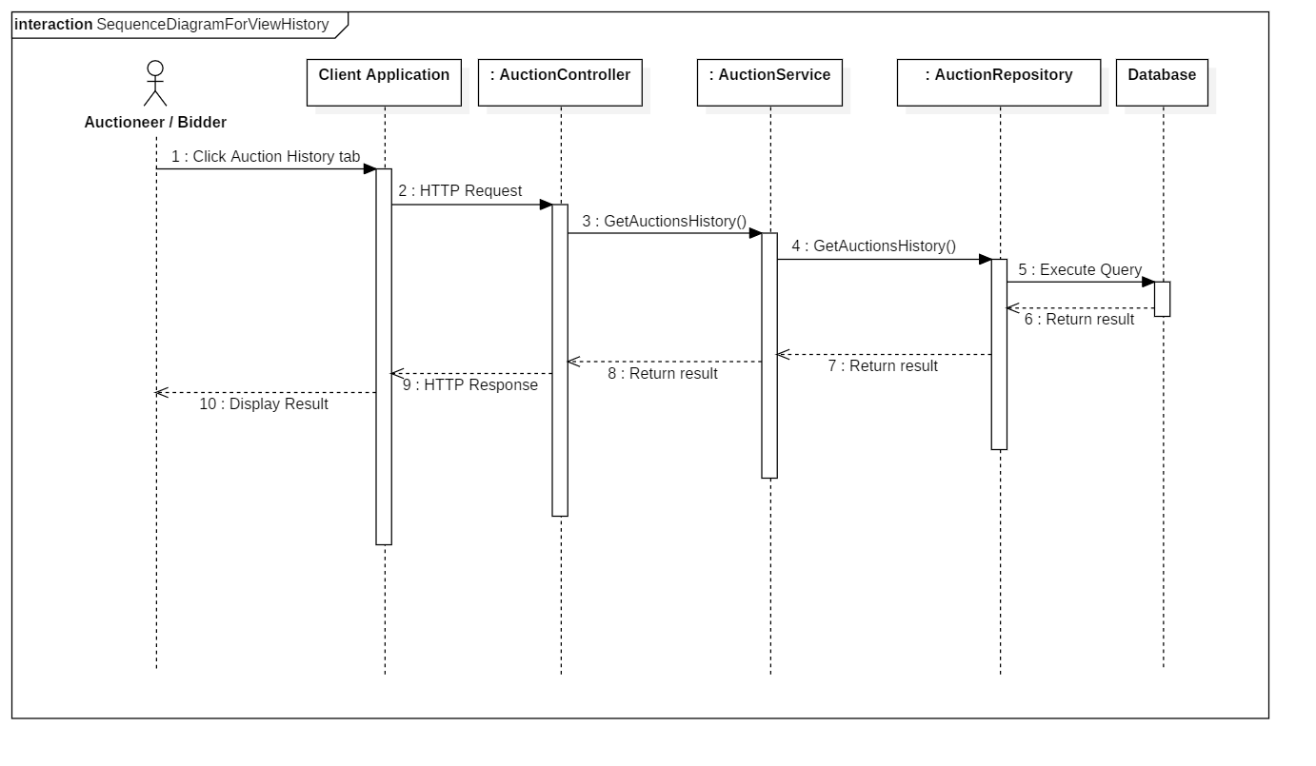

Figure 16 - Sequence Diagram for View Auction History < Auctioneer/Bidder >

##### Register address

Summary: this diagram shows process for register address.

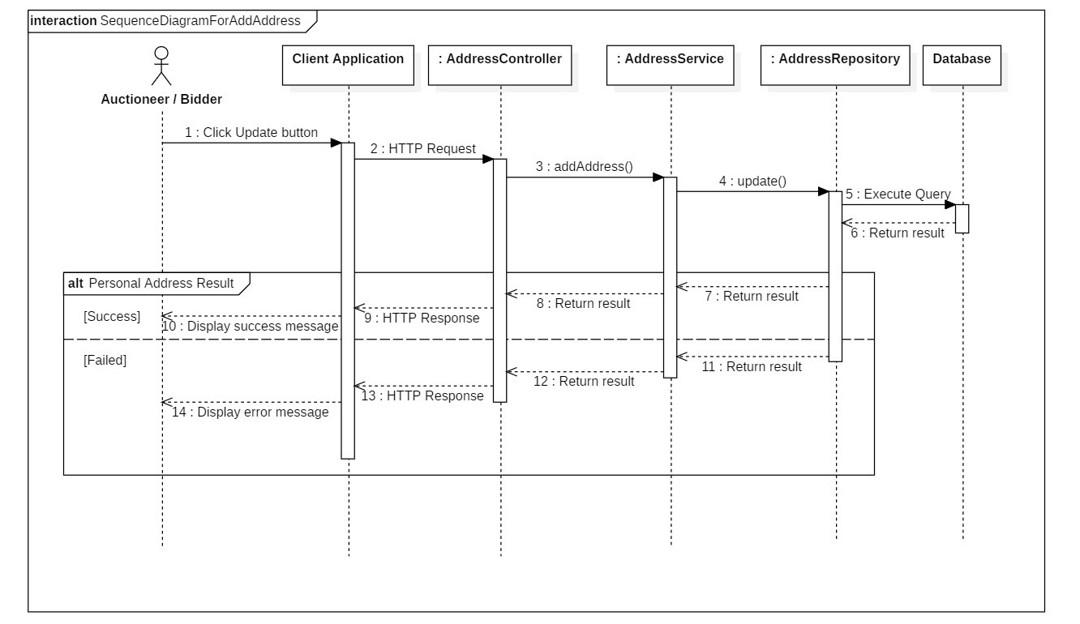

Figure 17 - Sequence Diagram for Register Address < Auctioneer/Bidder >

##### View Contact Information

Summary: this diagram shows process for view contact information of:

* winner of auction for seller
* seller of won auction for bidder

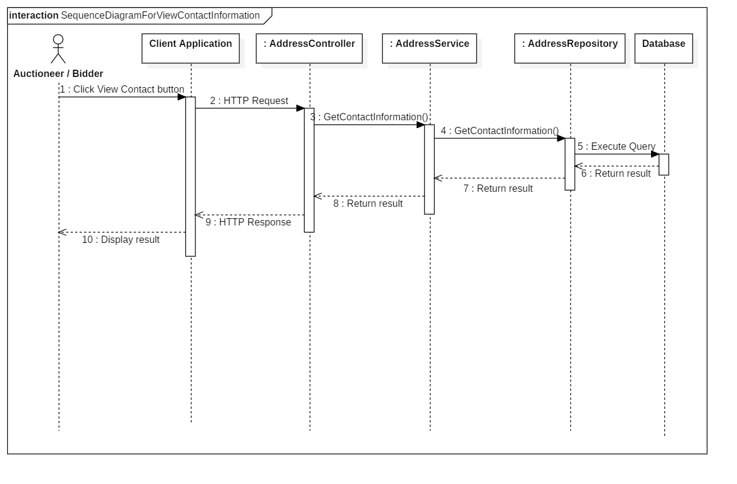

Figure 18 - Sequence Diagram for View Contact Information` < Auctioneer/Bidder >

### State Machine Diagram

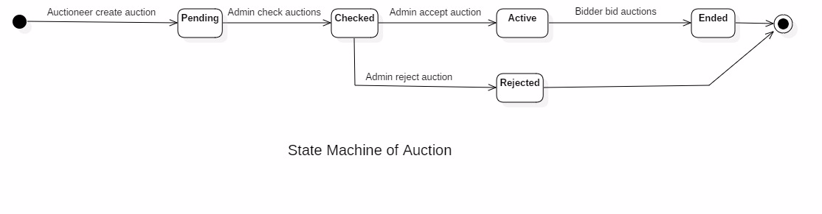

Figure 19 - State Machine Diagram of Auction

## **User Interface Design**

### Web admin application user interface

#### Login

# 

Figure 20 - Admin Web Interface <Login>

**Field**

|  |  |  |  |  |  |  |  |
| --- | --- | --- | --- | --- | --- | --- | --- |
| **No** | **Field Name** | **Description** | **Read only** | **Mandatory** | **Control Type** | **Data Type** | **Length** |
| 1 | Phone | Phone to login | No | Yes | Textbox | String |  |
| 2 | Password | Password to login | No | Yes | Textbox | String |  |
| 3 | Remember me | Auto log in | No | No | Checkbox | Boolean |  |

**Buttons/Hyperlinks:**

|  |  |  |  |  |
| --- | --- | --- | --- | --- |
| **No** | **Function** | **Description** | **Validation** | **Outcome** |
| 4 | Sign In | Login into system | Validate all required fields | Navigate to Admin page |

#### View Dashboard

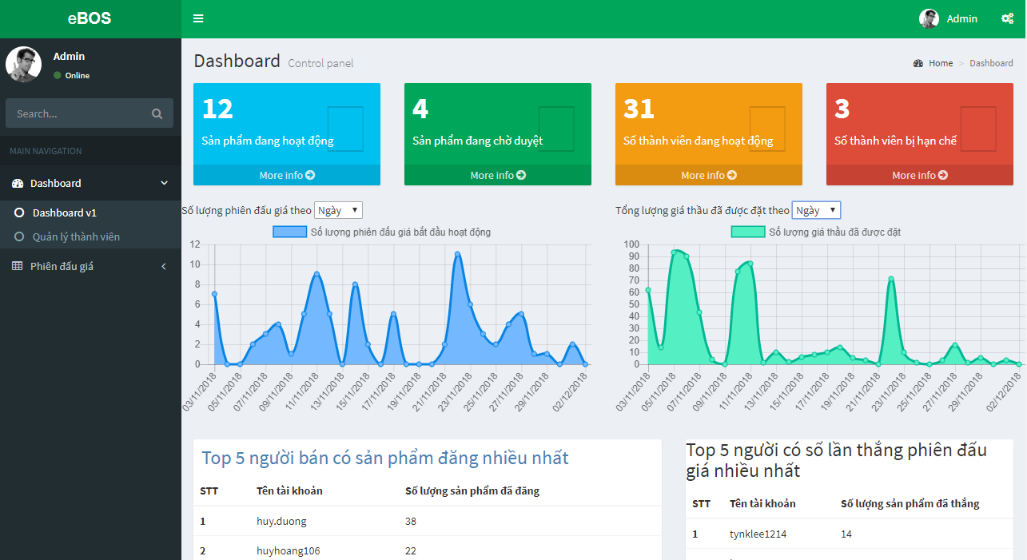

Figure 21 - Admin Web Interface <View Dashboard>

#### View User Management Page

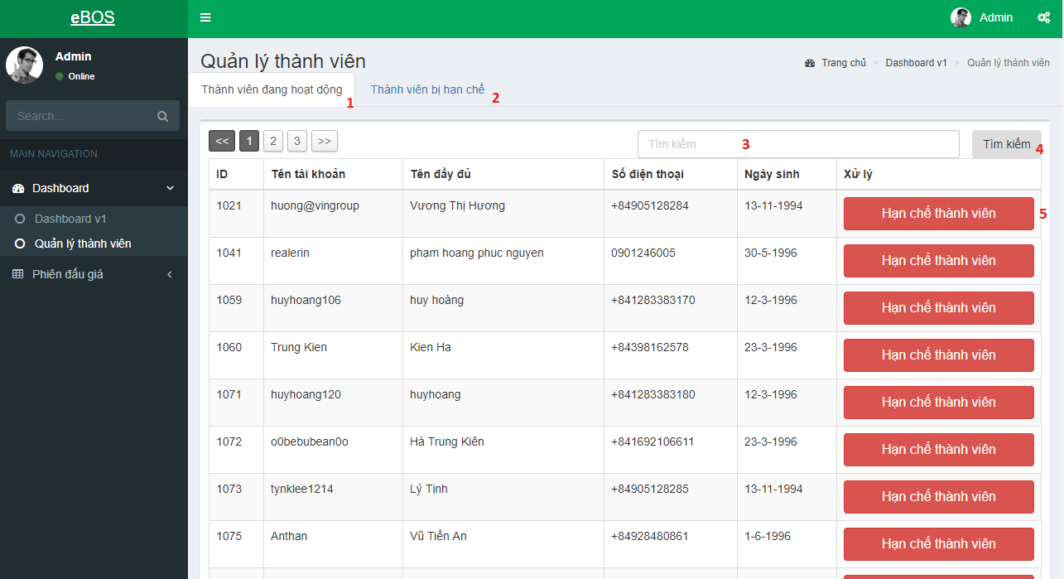

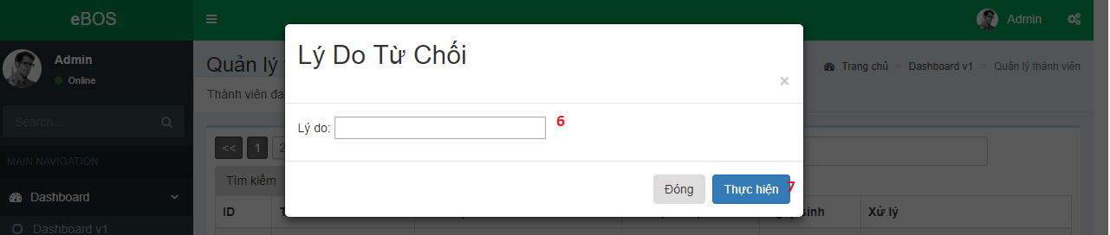

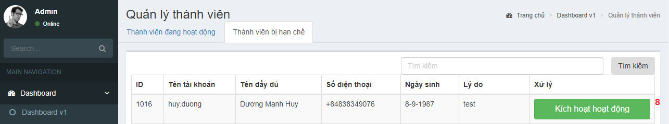

Figure 22 - Admin Web Interface <View User Management Page>

**Field**

|  |  |  |  |  |  |  |  |
| --- | --- | --- | --- | --- | --- | --- | --- |
| **No** | **Field Name** | **Description** | **Read only** | **Mandatory** | **Control Type** | **Data Type** | **Length** |
| 3 | Keyword Search | Fill Keyword to seach | No | Yes | Text | String |  |
| 6 | Reason | Fill reason to restrict user | No | Yes | Text | String |  |

**Buttons/Hyperlinks**

|  |  |  |  |  |
| --- | --- | --- | --- | --- |
| **No** | **Function** | **Description** | **Validation** | **Outcome** |
| 1 | Show Active Users | N/A | N/A | Show List of Active Users |
| 2 | Show Restrict Users | N/A | N/A | Show List of Restrict Users |
| 4 | Search User By Keyword | Search user by keyword and update list user | N/A | Search user and update list of users |
| 5 | Show Pop Up Restrict User | Show pop up for admin to give a note as reason for restricting user | N/A | Show pop up display a text input for admin to give a note as reason for restricting user |
| 7 | Restrict User | Restrict user and update list user | N/A | Restricts user and reload page |
| 8 | Active User | Active user and update list user | N/A | Activate user and reload page |

#### View Pending Auctions

# 

Figure 23 - Admin Web Interface <View Pending Auctions>

**Buttons/Hyperlinks:**

|  |  |  |  |  |
| --- | --- | --- | --- | --- |
| **No** | **Function** | **Description** | **Validation** | **Outcome** |
| 1 | Show images | Image of auction’s auction | N/A | Show popup displaying images |
| 2 | Accept Auction | Accept an auction | N/A | Update list |
| 3 | Refuse Auction | Refuse an auction | N/A | Update list |
| 4 | Show Details | View auction’s details | N/A | Show popup displaying auction’s details |

#### View List Auctions

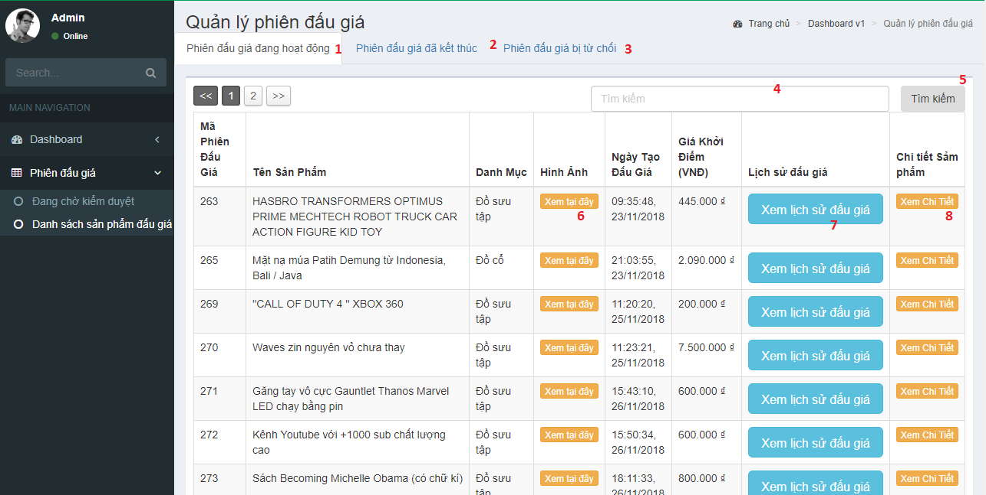

Figure 24 - Admin Web Interface <View List Auctions>

**Field**

|  |  |  |  |  |  |  |  |
| --- | --- | --- | --- | --- | --- | --- | --- |
| **No** | **Field Name** | **Description** | **Read only** | **Mandatory** | **Control Type** | **Data Type** | **Length** |
| 4 | Keyword Search | Fill Keyword to seach | No | Yes | Text | String |  |

**Buttons/Hyperlinks**

|  |  |  |  |  |
| --- | --- | --- | --- | --- |
| **No** | **Function** | **Description** | **Validation** | **Outcome** |
| 1 | Show Active Auctions | N/A | N/A | Show List of Active Auctions |
| 2 | Show Ended Auctions | N/A | N/A | Show List of Ended Auctions |
| 3 | Show Rejected Auctions | N/A | N/A | Show List of Rejected Auctions |
| 4 | Search Auctions By Keyword | Search auction by keyword and update list of auctions | N/A | Search user and update list of auctions |
| 5 | View Images | Show pop up displaying all images | N/A | Show pop up displaying all images |
| 7 | View bidding history | Show pop up view bidding history(Only Active and Ended Auction Tab) | N/A | Show pop up and view bidding history |
| 8 | View Detail | Show pop up view detail of auction | N/A | Show pop up and view detail of auction |

### Web application user interface

#### Login/Register



Figure 25 - Web Interface <Login/Register/Search>

**Field**

|  |  |  |  |  |  |  |  |
| --- | --- | --- | --- | --- | --- | --- | --- |
| **No** | **Field Name** | **Description** | **Read only** | **Mandatory** | **Control Type** | **Data Type** | **Length** |
| 3 | Keyword Search | Fill Keyword to seach | No | Yes | Text | String |  |

**Buttons/Hyperlinks**

|  |  |  |  |  |
| --- | --- | --- | --- | --- |
| **No** | **Function** | **Description** | **Validation** | **Outcome** |
| 1 | Show Login form | N/A | N/A | Show Login form as a modal |
| 2 | Show Register form | N/A | N/A | Show Register form as a modal |
| 4 | Navigate to Search Auction By Keyword Page | Navigate to Search Auction By Keyword Page with keyword as paramater of url | Validate all required fields | Navigate to Search Auction By Keyword Page |
| 5 | Logo | Navigate to home page | N/A | Navigate to home page |

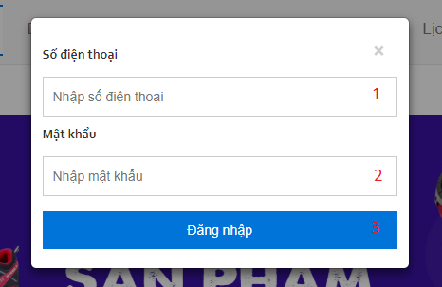

Figure 26 - Web Interface <Login Popup>

**Field**

|  |  |  |  |  |  |  |  |
| --- | --- | --- | --- | --- | --- | --- | --- |
| **No** | **Field Name** | **Description** | **Read only** | **Mandatory** | **Control Type** | **Data Type** | **Length** |
| 1 | Phone | Fill Phone | No | Yes | Text | String |  |
| 2 | Password | Fill Password | No | Yes | Password | String |  |

**Buttons/Hyperlinks:**

|  |  |  |  |  |
| --- | --- | --- | --- | --- |
| **No** | **Function** | **Description** | **Validation** | **Outcome** |
| 3 | Sign In | Login into system | Validate all required fields | Navigate to Home page |

 Figure 1 - Web Interface <Logout>

|  |  |  |  |  |  |  |
| --- | --- | --- | --- | --- | --- | --- |
| No | Field Name | Description | Read only | Mandatory | Control Type | Data Type |
| 1 | Firstcharacter | The first character of username (default avatar) | No | Yes | Text | String |
| 2 | Username | Logged in Username | No | Yes | Dropdown-toggle | String |

**Buttons/Hyperlinks**

|  |  |  |  |  |
| --- | --- | --- | --- | --- |
| **No** | **Function** | **Description** | **Validation** | **Outcome** |
| 3 | Log Out | Click to logout | N/A | Navigate to Home Page |

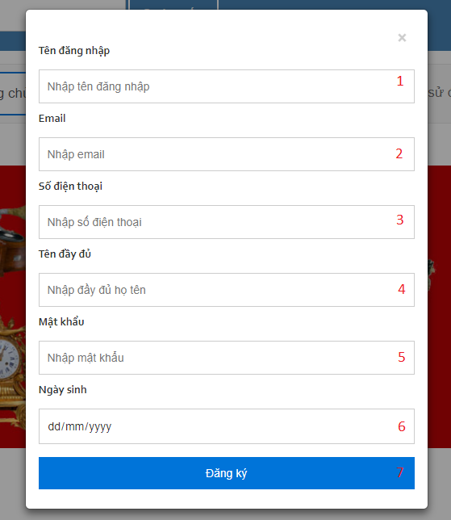

Figure 27 - Web Interface <Register account>

**Field**

|  |  |  |  |  |  |  |  |
| --- | --- | --- | --- | --- | --- | --- | --- |
| **No** | **Field Name** | **Description** | **Read only** | **Mandatory** | **Control Type** | **Data Type** | **Length** |
| 1 | userName | Fill user name | No | Yes | Text | String |  |
| 2 | email | Fill email | No | Yes | Text | String |  |
| 3 | phone | Fill phone | No | Yes | Text | Number |  |
| 4 | fullName | Fill full name | No | Yes | Text | String |  |
| 5 | Password | Fill password | No | Yes | Password | String |  |
| 6 | dateOfBirth | Fill date of birth | No | Yes | Date | Date |  |

**Buttons/Hyperlinks:**

|  |  |  |  |  |
| --- | --- | --- | --- | --- |
| **No** | **Function** | **Description** | **Validation** | **Outcome** |
| 7 | Register | Click to register | N/A | Navigate to Home page |

#### Nav Bar



Figure 28 - Web Interface <Menu bar and Categories>

**Buttons/Hyperlinks:**

|  |  |  |  |  |
| --- | --- | --- | --- | --- |
| **No** | **Function** | **Description** | **Validation** | **Outcome** |
| 1 | Navigate to Home Page | N/A | N/A | Navigate to Home Page |
| 2 | Show Categories | Show list of categories as a drop down list | N/A | Show list of categories as a drop down list |
| 3 | Navigate to Introduction Page | N/A | N/A | Navigate to Introduction Page |
| 4 | Navigate to Submit Auction Page | N/A | User must had been authorized. | Navigate to Submit Auction Page |
| 5 | Navigate to Auction History | N/A | User must had been authorized. | Navigate to Auction History |

#### Home Page - List of auctions

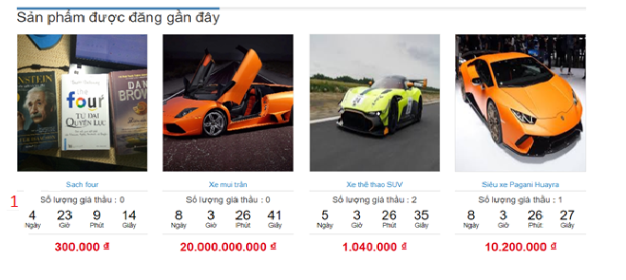

Figure 29 - Web Interface <Home page - Newly listed auctions>

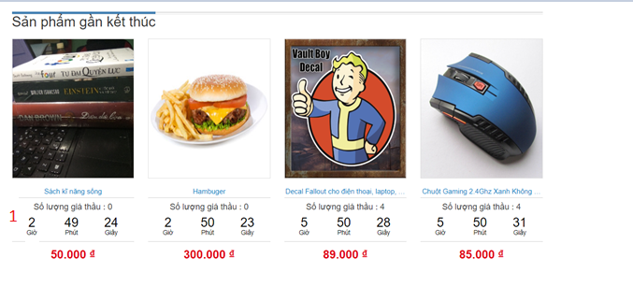

Figure 30 - Web Interface <Home page - Ending soon auctions>

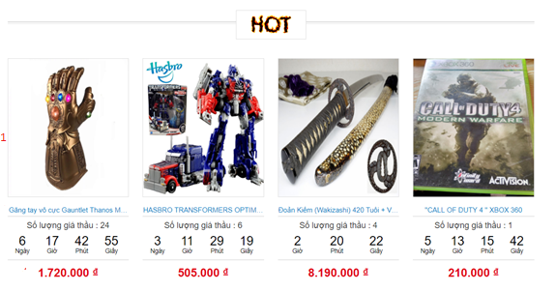

Figure 31 - Web Interface <Home page - Highest number of bids >

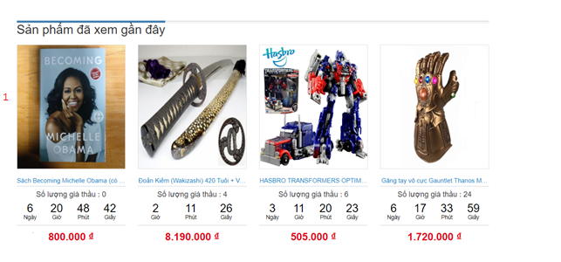

Figure 32 - Web Interface <Home page - Recently viewed auctions >

**Buttons/Hyperlinks:**

|  |  |  |  |  |
| --- | --- | --- | --- | --- |
| **No** | **Function** | **Description** | **Validation** | **Outcome** |
| 1 | Navigate to Auction Details page | Navigate to Auction Details page that showing chosen auction’ details | N/A | Navigate to Auction Details page |

#### Submit Auction

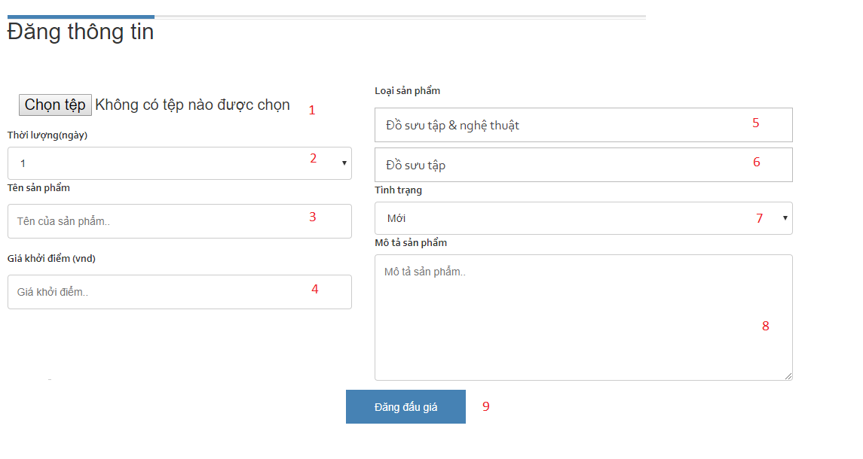

Figure 33 - Web Interface <Submit Auction>

**Field**

|  |  |  |  |  |  |  |  |
| --- | --- | --- | --- | --- | --- | --- | --- |
| **No** | **Field Name** | **Description** | **Read only** | **Mandatory** | **Control Type** | **Data Type** | **Length** |
| 1 | Image Picker | Pick one or more images for item | No | Yes | File-chooser | File |  |
| 2 | Duration | Auction’s duration | No | Yes | Dropdown List | String |  |
| 3 | Name | Fill item’s name | No | Yes | Text | String |  |
| 4 | Reserve Price | Fill reserve price | No | Yes | Text | String |  |
| 5 | Parent Categories | Dropdown list of main categories | No | Yes | Dropdown List | String |  |
| 6 | Sub Categories | dropdown list of sub categories of chosen parent one | No | Yes | Dropdown List | String |  |
| 7 | Condition | Item’s conditon | No | Yes | Dropdown List | String |  |
| 8 | Description | Item’s description of | No | Yes | Text area | String |  |

**Buttons/Hyperlinks**

|  |  |  |  |  |
| --- | --- | --- | --- | --- |
| **No** | **Function** | **Description** | **Validation** | **Outcome** |
| 9 | Submit Auction | Get all input and submit them to system | Validate all required fields | Show success confirmation modal |

#### Search auctions by category

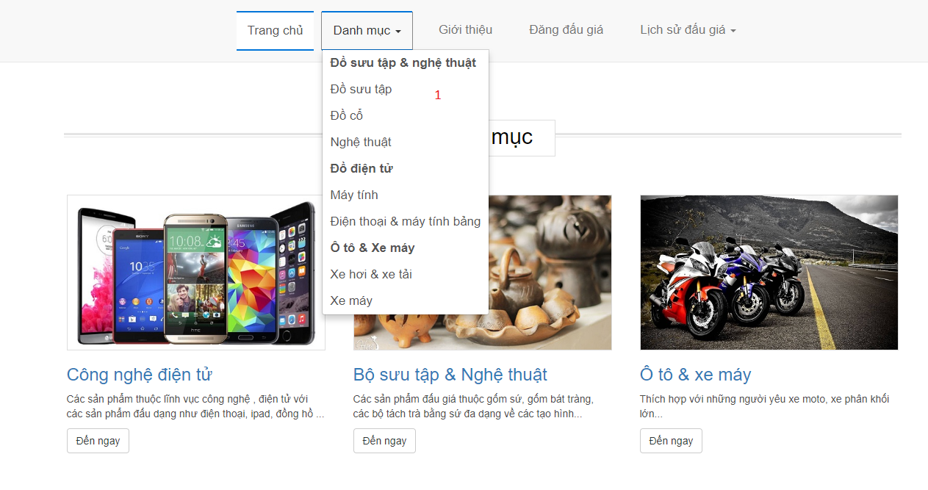

Figure 34 - Web Interface <Dropdown list of categories>

**Buttons/Hyperlinks**

|  |  |  |  |  |
| --- | --- | --- | --- | --- |
| **No** | **Function** | **Description** | **Validation** | **Outcome** |
| 1 | Navigate to Auctions by Category Page | When user clicks on any sub category, navigate to a page showing auctions whose item belonging to | N/A | Navigate to a page showing auctions whose item belonging to (Auctions by Category Page) |

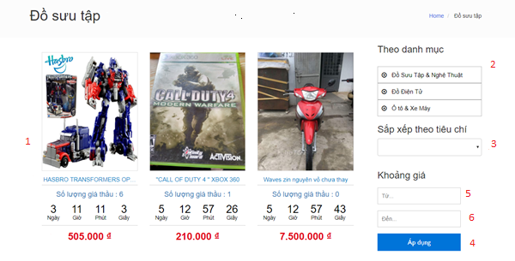

Figure 35 - Web Interface <Auctions By Category>

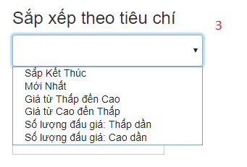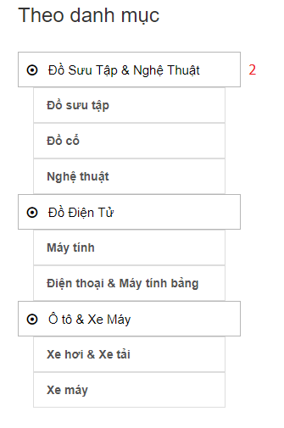

Figure 36 - Web Interface < Categories bar and sort>

**Field**

|  |  |  |  |  |  |  |  |
| --- | --- | --- | --- | --- | --- | --- | --- |
| **No** | **Field Name** | **Description** | **Read only** | **Mandatory** | **Control Type** | **Data Type** | **Length** |
| 5 | MinPrice | Input minimum price to filter | No | No | Text | String |  |
| 6 | MaxPrice | Input maximum price to filter | No | No | Text | String |  |

**Buttons/Hyperlinks:**

|  |  |  |  |  |
| --- | --- | --- | --- | --- |
| **No** | **Function** | **Description** | **Validation** | **Outcome** |
| 1 | Navigate to Auction Details page | When clicking each auction, navigate to Auction Details Page | N/A | Navigate to Auction Details page |
| 2 | Reload | Reload page | N/A | Reload page and display auctions by chosen category |
| 3 | Sort | Sort the list of auctions | N/A | Reload page and show sorted list of auctions |
| 4 | Filter | Filter the list of auctions with minimum price and maximum price | Minimum price >= 1.000 (vnd) and Max price <= 2.000.000.000 (vnd) | Reload page and show filtered list of auctions |

#### Bidding History

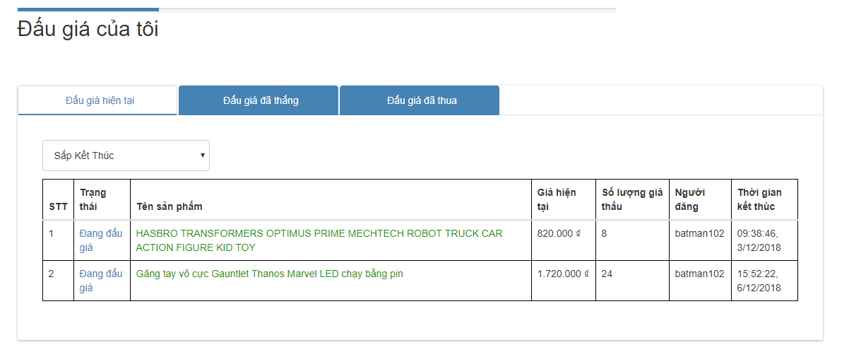

Figure 37 - Web Interface <Bidding Auctions History>

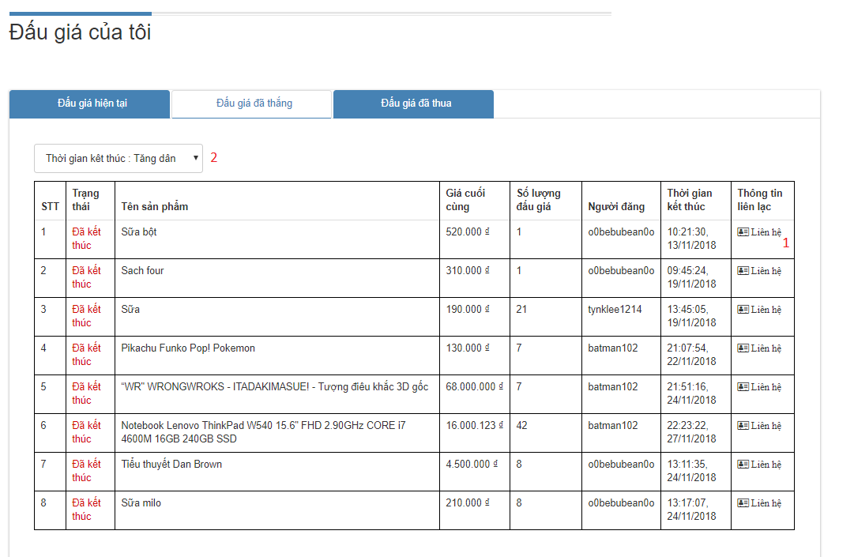

Figure 38 - Web Interface <Won Auctions History>

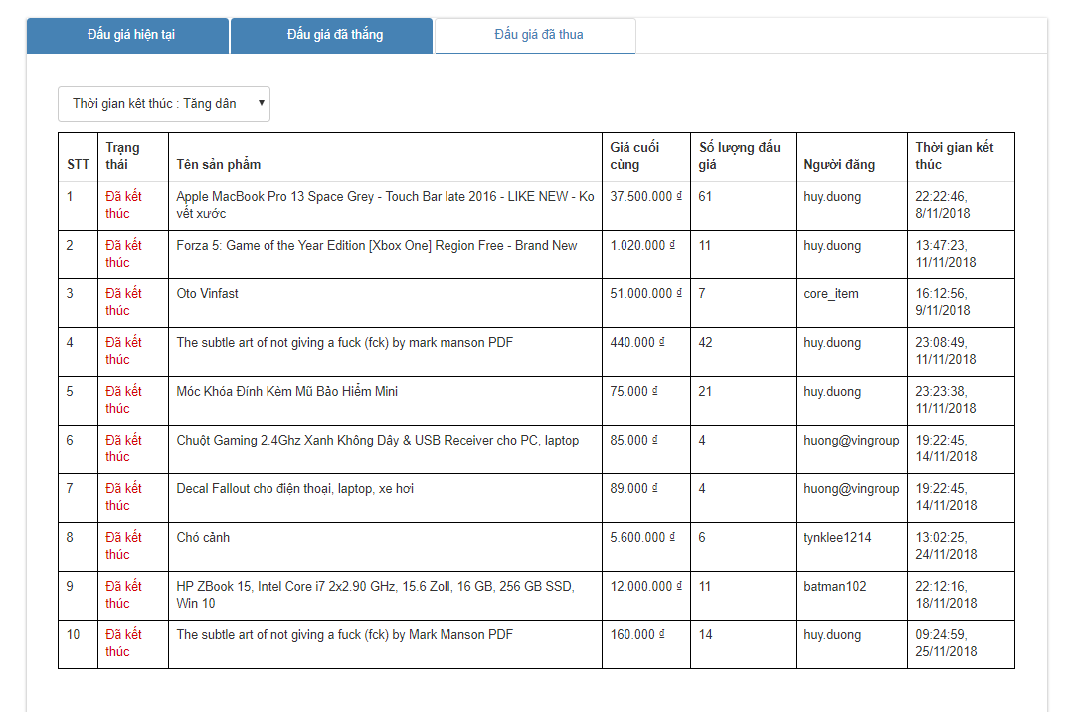

Figure 39 - Web Interface <Lost Auctions History>

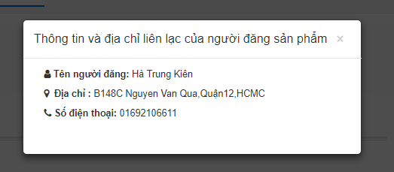

Figure 40 - Web Interface <Contact Seller>

**Buttons/Hyperlinks**

|  |  |  |  |  |
| --- | --- | --- | --- | --- |
| **No** | **Function** | **Description** | **Validation** | **Outcome** |
| 1 | Show Pop Up Contact | Show popup contact of seller of won auction | Token | Show popup contact of seller of won auction |
| 2 | Sort History | Sort history records | N/A | Show sorted List of auctions |

#### Selling History

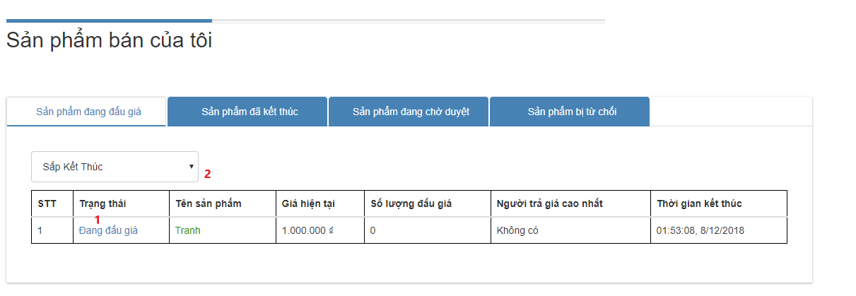

Figure 41 - Web Interface <Active Auctions History>

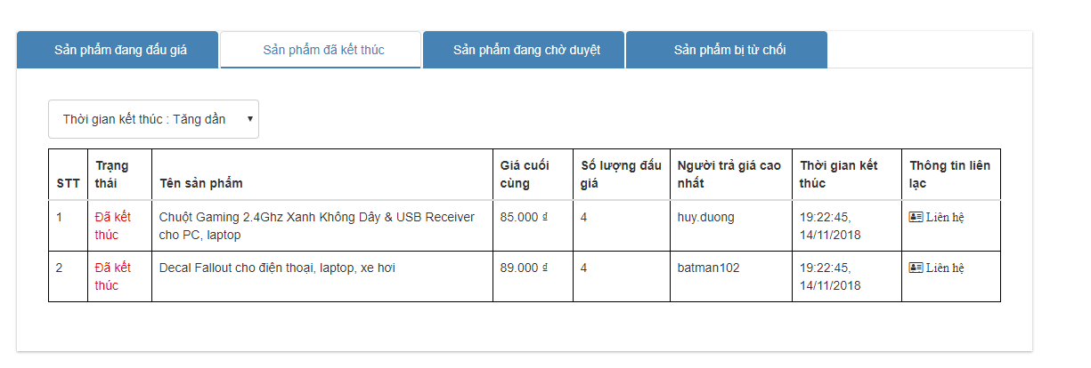

Figure 42 - Web Interface <Ended Auctions History>

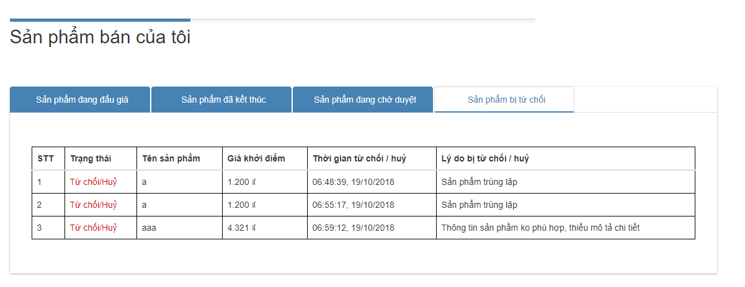

Figure 43 - Web Interface <Rejected Auctions History>

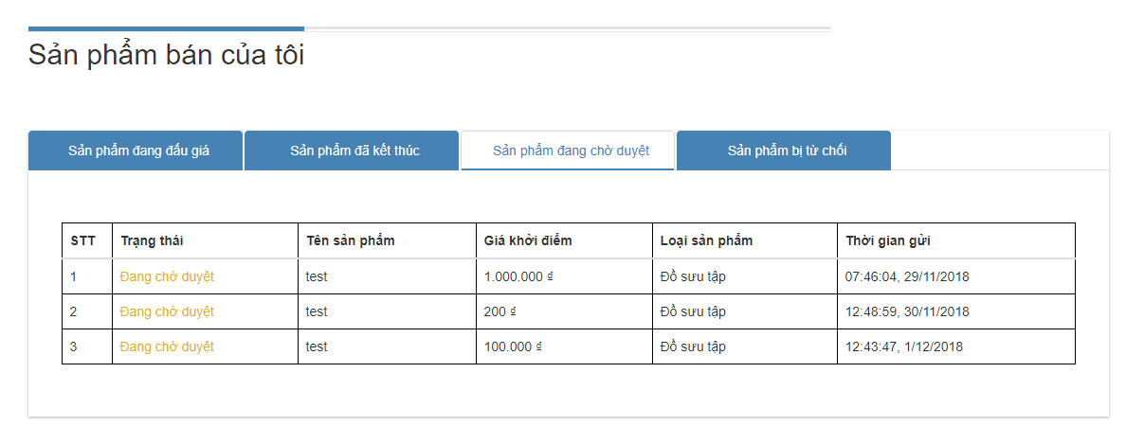

Figure 44 - Web Interface <Pending Auctions History>

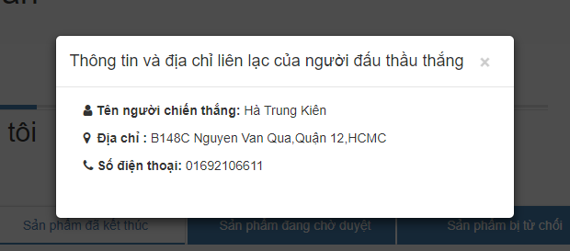

Figure 45 - Web Interface <Contact Bidder>

**Buttons/Hyperlinks**

|  |  |  |  |  |
| --- | --- | --- | --- | --- |
| **No** | **Function** | **Description** | **Validation** | **Outcome** |
| 1 | Show Pop Up Contact | Show popup contact of winner of won auction | Token | Show popup contact of winner of won auction |
| 2 | Sort History | Sort history records | N/A | Show sorted List of auctions |

#### Auction Details

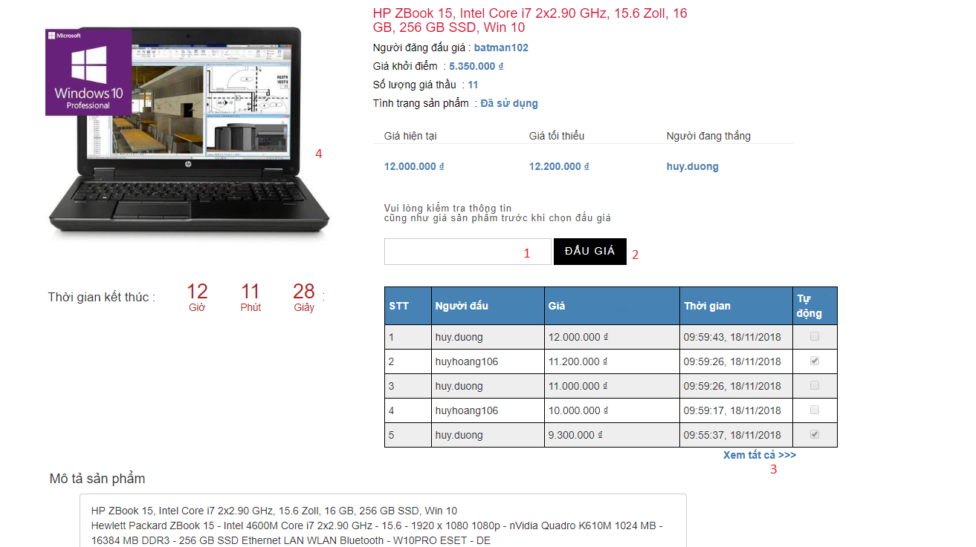

Figure 46 - Web Interface <Auction Details>

**Field**

|  |  |  |  |  |  |  |  |
| --- | --- | --- | --- | --- | --- | --- | --- |
| **No** | **Field Name** | **Description** | **Read only** | **Mandatory** | **Control Type** | **Data Type** | **Length** |
| 1 | Bid Price | Fill Bid’s Price | No | Yes | Text | Number |  |

**Buttons/Hyperlinks**

|  |  |  |  |  |
| --- | --- | --- | --- | --- |
| **No** | **Function** | **Description** | **Validation** | **Outcome** |
| 2 | Show confirm popup | Show popup to confirm for place bid | Validate all required info. Price must equals or higher than 1000 and divisible by 500 | Show popup to confirm for place bid |
| 3 | View Bidding Hitory | View Biddng History of the Auction | N/A | Show popup displaying list of bids at the auction |
| 4 | View Images | Show lightbox displaying images of the auction | N/A | Show lightbox displaying images of the auction |

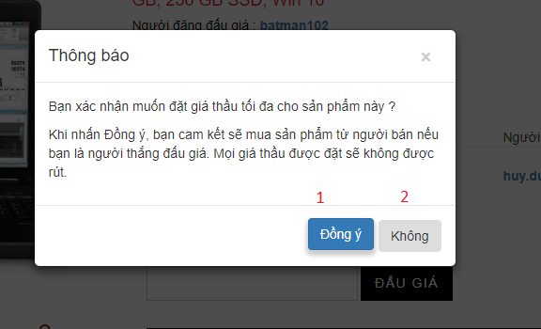

Figure 47 - Web Interface <Confirm to place bid>

**Buttons/Hyperlinks:**

|  |  |  |  |  |
| --- | --- | --- | --- | --- |
| **No** | **Function** | **Description** | **Validation** | **Outcome** |
| 1 | Place Bid | N/A | N/A | Popup is closed and Success confirmation popup will be shown |
| 2 | Close | N/A | N/A | Close the popup |

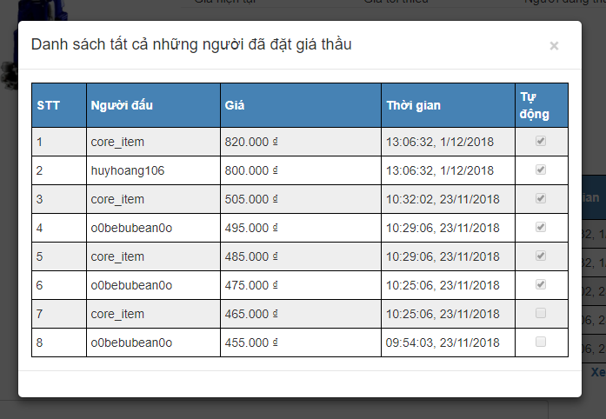

Figure 48 - Web Interface <Bidding History>

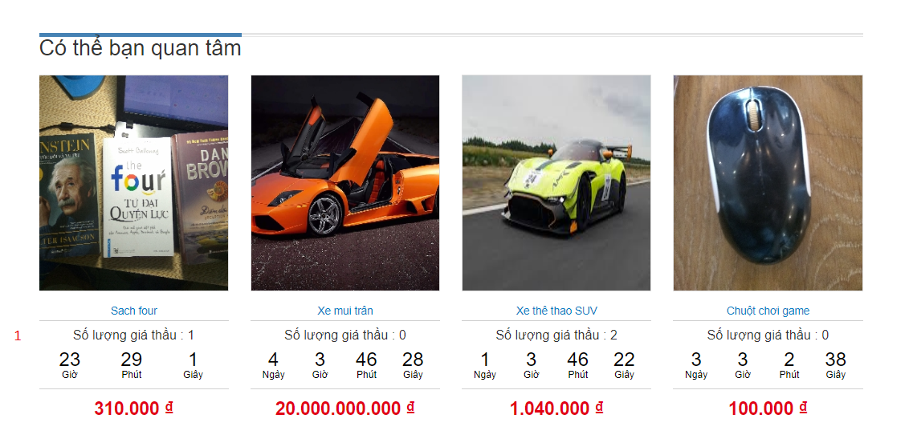

Figure 49 - Web Interface <Recommended Auctions>

**Buttons/Hyperlinks**

|  |  |  |  |  |
| --- | --- | --- | --- | --- |
| **No** | **Function** | **Description** | **Validation** | **Outcome** |
| 1 | Navigate to Auction Details page | N/A | N/A | Navigate to Auction Detailss page |

#### Search By Keyword Result

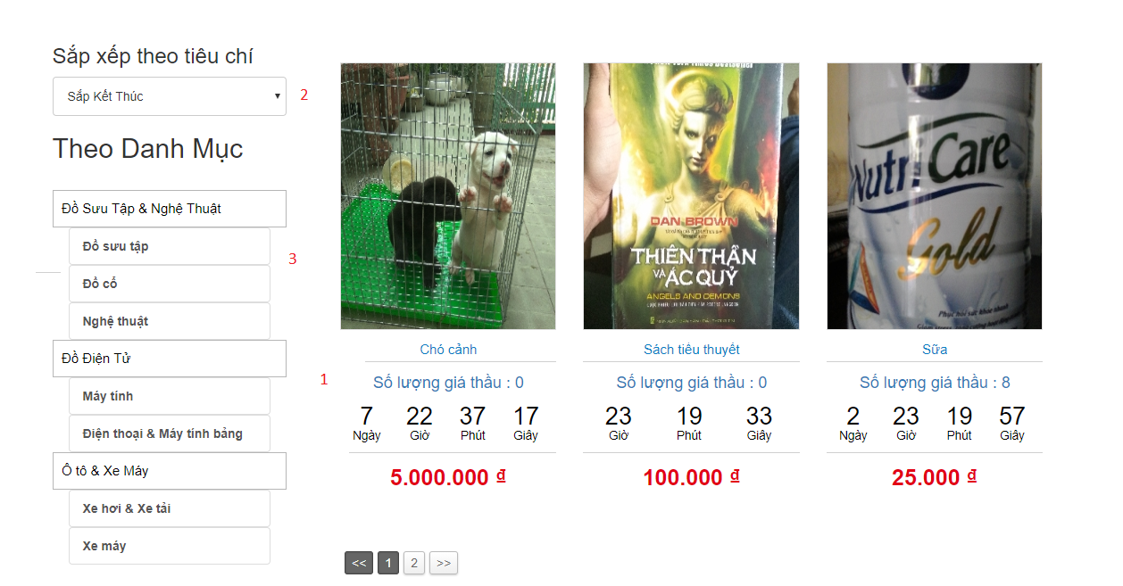

Figure 50 - Web Interface <Search By Keyword Result>

**Buttons/Hyperlinks**

|  |  |  |  |  |
| --- | --- | --- | --- | --- |
| **No** | **Function** | **Description** | **Validation** | **Outcome** |
| 1 | Navigate to Auction Detailss page | N/A | N/A | Navigate to Auction Detailss page |
| 2 | Sort auctions | N/A | N/A | Display sorted auctions |
| 3 | Navigate to Auctions By Category Page | N/A | N/A | Navigate to Auctions By Category Page |

#### Register address

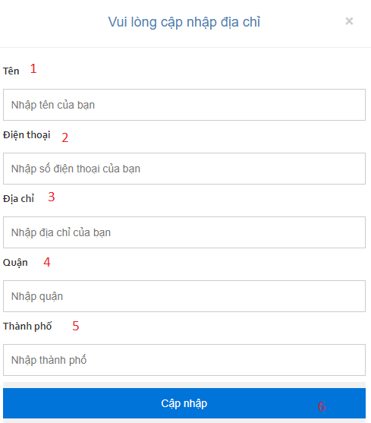

Figure 51 - Web Interface <Register address>

**Field**

|  |  |  |  |  |  |  |  |
| --- | --- | --- | --- | --- | --- | --- | --- |
| **No** | **Field Name** | **Description** | **Read only** | **Mandatory** | **Control Type** | **Data Type** | **Length** |
| 1 | username | Fill user name | No | Yes | Text | String |  |
| 2 | phone | Fill phone | No | Yes | Text | Number |  |
| 3 | address | Fill adress | No | Yes | Text | String |  |
| 4 | district | Fill district | No | Yes | Text | String |  |
| 5 | city | Fill city | No | Yes | Text | String |  |

**Buttons/Hyperlinks**

|  |  |  |  |  |
| --- | --- | --- | --- | --- |
| **No** | **Function** | **Description** | **Validation** | **Outcome** |
| 6 | Register Address | Click to register | N/A | Show success confirmation popup |

### Mobile application user interface

#### Opening Page

`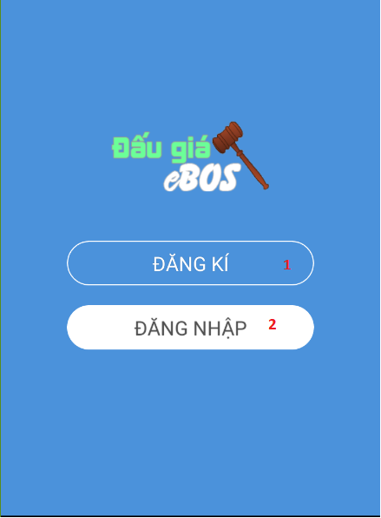

Figure 52 - Mobile Interface <Opening>

**Buttons/Hyperlinks:**

|  |  |  |  |  |
| --- | --- | --- | --- | --- |
| **No** | **Function** | **Description** | **Validation** | **Outcome** |
| 1 | Navigate to Register page | N/A | N/A | Navigate to Register page |
| 2 | Navigate to Login page | N/A | N/A | Navigate to Register page |

#### Login page

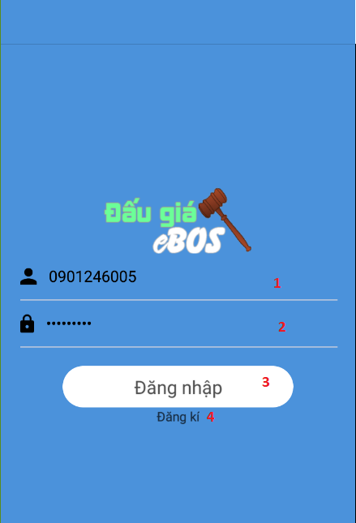

Figure 53 - Mobile Interface <Login>

**Field**

|  |  |  |  |  |  |  |  |
| --- | --- | --- | --- | --- | --- | --- | --- |
| **No** | **Field Name** | **Description** | **Read only** | **Mandatory** | **Control Type** | **Data Type** | **Length** |
| 1 | Phone | Phone to login | No | Yes | Textbox | String |  |
| 2 | Password | Password to login | No | Yes | Textbox | String |  |

**Buttons/Hyperlinks:**

|  |  |  |  |  |
| --- | --- | --- | --- | --- |
| **No** | **Function** | **Description** | **Validation** | **Outcome** |
| 3 | Sign In | Login into system | Validate all required fields | Navigate to Home page |
| 4 | Navigate to Register Page | N/A | N/A | Navigate to Register Page |

#### Update Address

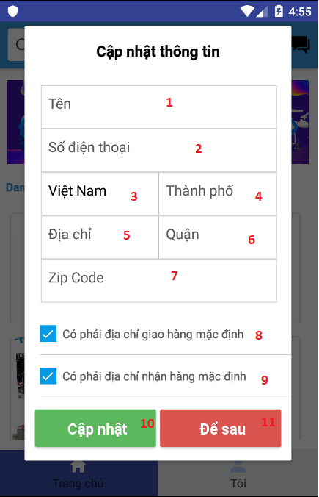

Figure 54 - Mobile Interface < Update address>

**Field**

|  |  |  |  |  |  |  |  |
| --- | --- | --- | --- | --- | --- | --- | --- |
| **No** | **Field Name** | **Description** | **Read only** | **Mandatory** | **Control Type** | **Data Type** | **Length** |
| 1 | Name | Name of user | No | Yes | Textbox | String |  |
| 2 | Phone | Phone of user | No | Yes | Textbox | String |  |
| 3 | Country | Country of user | No | Yes | Textbox | String |  |
| 4 | City | City of user | No | Yes | Textbox | String |  |
| 5 | Address | Address of user | No | Yes | Textbox | String |  |
| 6 | District | District of user | No | Yes | Textbox | String |  |
| 7 | Zip code | Zip code of user | No | Yes | Textbox | String |  |
| 8 | Shipping primary | Check box is shipping primary | Yes | Yes | Checkbox | boolean |  |
| 9 | Ship primary | Check box is ship primary | Yes | Yes | Checkbox | boolean |  |

**Buttons/Hyperlinks:**

|  |  |  |  |  |
| --- | --- | --- | --- | --- |
| **No** | **Function** | **Description** | **Validation** | **Outcome** |
| 10 | Update address | Update address | N/A | Update address and close modal |
| 11 | Close | Close modal | N/A | Close modal |

#### Register Account page

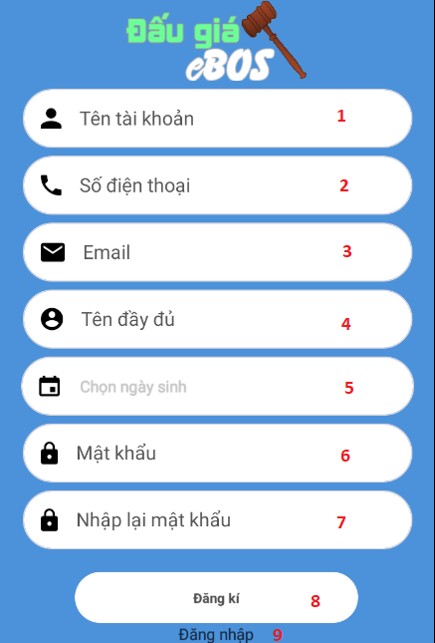

Figure 55 - Mobile Interface <Register account>

**Field**

|  |  |  |  |  |  |  |  |
| --- | --- | --- | --- | --- | --- | --- | --- |
| **No** | **Field Name** | **Description** | **Read only** | **Mandatory** | **Control Type** | **Data Type** | **Length** |
| 1 | Username | Username to register | No | Yes | Textbox | String |  |
| 2 | Phone | Phone to register | No | Yes | Textbox | String |  |
| 3 | Email | Email to register | No | Yes | Textbox | String |  |
| 4 | Full name | Fullname to register | No | Yes | Textbox | String |  |
| 5 | Date of Birth | D.O.B to register | No | Yes | Datepicker | Date |  |
| 6 | Password | Password to register | No | Yes | Textbox | String |  |
| 7 | Re-Password | Re-Password to confirm password | No | Yes | Textbox | String |  |

**Buttons/Hyperlinks:**

|  |  |  |  |  |
| --- | --- | --- | --- | --- |
| **No** | **Function** | **Description** | **Validation** | **Outcome** |
| 8 | Register | Register into system | Validate all required fields | Navigate to Phone verify page, then navigate to Login Page |
| 9 | Navigate to Login Page | N/A | N/A | Navigate to Login Page |

#### Home page

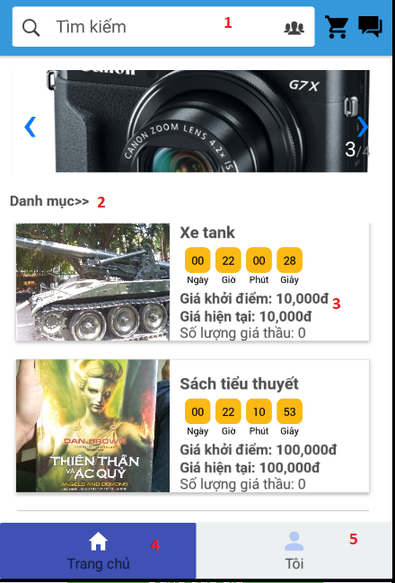

Figure 56 - Mobile Interface <Home>

**Buttons/Hyperlinks:**

|  |  |  |  |  |
| --- | --- | --- | --- | --- |
| **No** | **Function** | **Description** | **Validation** | **Outcome** |
| 1 | Search bar | When focus on the field, Navigate to search page | N/A | Navigate to Search page |
| 2 | Category | Show all categories | N/A | Navigate to category page |
| 3 | Show auction’s auction detailss | View auction’s auction detailss | N/A | Navigate to auction’s auction details page |
| 4 | Navigate to Home Page | N/A | N/A | Navigate to Home Page |
| 5 | Navigate to Personal Page | N/A | N/A | Navigate to Personal Page |

#### Auction Detailss Page

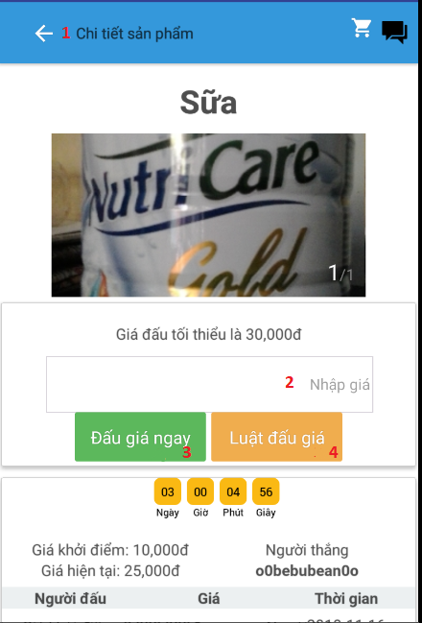

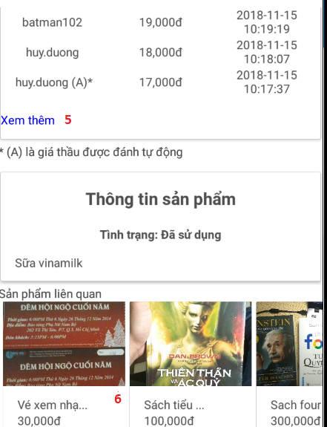

Figure 57 - Mobile Interface <Auction Details>

**Field**

|  |  |  |  |  |  |  |  |
| --- | --- | --- | --- | --- | --- | --- | --- |
| **No** | **Field Name** | **Description** | **Read only** | **Mandatory** | **Control Type** | **Data Type** | **Length** |
| 2 | Bid Price | Price to bid | No | Yes | Textbox | String |  |

**Buttons/Hyperlinks:**

|  |  |  |  |  |
| --- | --- | --- | --- | --- |
| **No** | **Function** | **Description** | **Validation** | **Outcome** |
| 1 | Back | Back to previous page | N/A | Go to previous page |
| 3 | Place Bid | Submit price to bid | N/A | Show popup of success confirmation |
| 5 | Show rule | Show rule of bidding | N/A | Show rule of bidding |
| 6 | View bids | Show all bidding history of auction | N/A | Show popup bidding history of auction |
| 6 | View recommended auction | View detailss of auction | N/A | Reload details screen with chosen auction |

#### Personal page

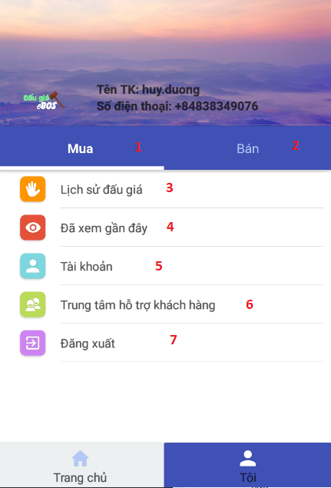

Figure 58 - Mobile Interface <Personal>

**Buttons/Hyperlinks:**

|  |  |  |  |  |
| --- | --- | --- | --- | --- |
| **No** | **Function** | **Description** | **Validation** | **Outcome** |
| 1 | Navigate to Bidding Page | N/A | N/A | Navigate to Bidding Page |
| 2 | Navigate to Selling Page | N/A | N/A | Navigate to Selling Page |
| 3 | View Bidding History | N/A | N/A | Navigate to history page |
| 4 | View List Recent Viewed | N/A | N/A | Navigate to Recent viewed page |
| 5 | View Profile Information | View profile information (Not implemented) | N/A | Navigate to profile information page |
| 6 | View Support Center | View phone number of support center (Not implemented) | N/A | Show popup of support center’s contact information |
| 7 | Log out | Log out from system | N/A | Navigate to opening page |

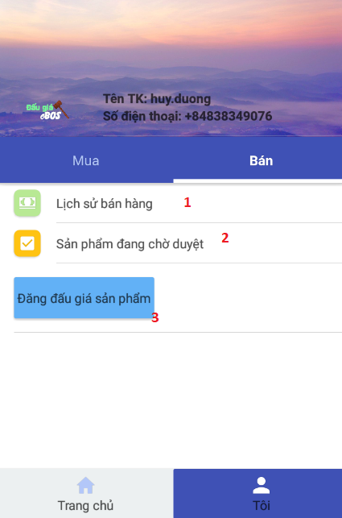

Figure 59 - Mobile Interface <Selling> interface

**Buttons/Hyperlinks:**

|  |  |  |  |  |
| --- | --- | --- | --- | --- |
| **No** | **Function** | **Description** | **Validation** | **Outcome** |
| 1 | View Selling history | N/A | N/A | Navigate to history of selling page |
| 2 | View Pending auction | N/A | N/A | Navigate to Pending auction page |
| 2 | Navigate to Submit Auction Page | N/A | N/A | Navigate to Submit Auction Page |
|  |  |  |  |  |

#### Bidding History page

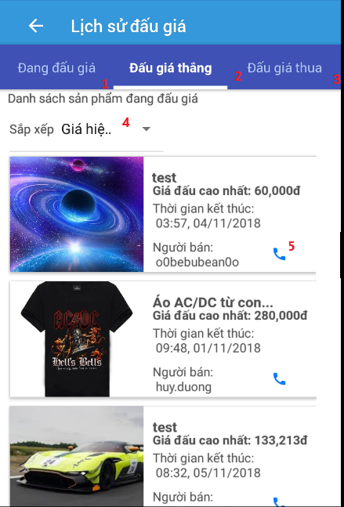

Figure 60 - Mobile Interface <Bidding History>

**Buttons/Hyperlinks:**

|  |  |  |  |  |
| --- | --- | --- | --- | --- |
| **No** | **Function** | **Description** | **Validation** | **Outcome** |
| 1 | View bidding auctions | N/A | N/A | Switch to show all bidding auction |
| 2 | View won auctions | N/A | N/A | Switch to show all won auction |
| 3 | View lost auctions | N/A | N/A | Switch to show all lost bids |
| 4 | Sort auctions | Sort auctions by number of bids, end time, current price | N/A | Show list of sorted auctions |
| 5 | View seller’s contact infomation | View seller’s contact information: phone, address. Only supported for won auctions | N/A | Show popup of seller’s contact information |

#### Selling History page

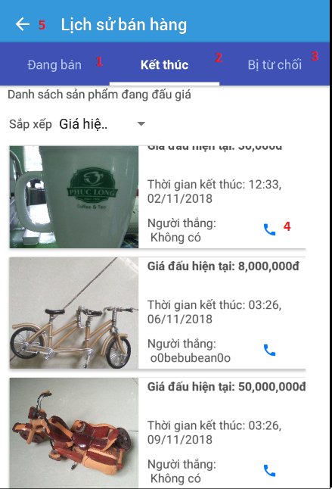

Figure 11 - Mobile Interface <Selling History>

**Buttons/Hyperlinks:**

|  |  |  |  |  |
| --- | --- | --- | --- | --- |
| **No** | **Function** | **Description** | **Validation** | **Outcome** |
| 1 | View selling auctions | N/A | N/A | Switch tab to show all selling auctions |
| 2 | View ended auctions | N/A | N/A | Switch tab to show all ended auctions |
| 3 | View rejected | N/A | N/A | Switch tab to show all rejected auction |
| 4 | View winner’s contact information | View winner’s contact information: phone, address. Only supported for ended auction. | N/A | Show popup to display winner contact information |
| 5 | Back | Back previous page | N/A | Back previous page |

#### Submit Auction page

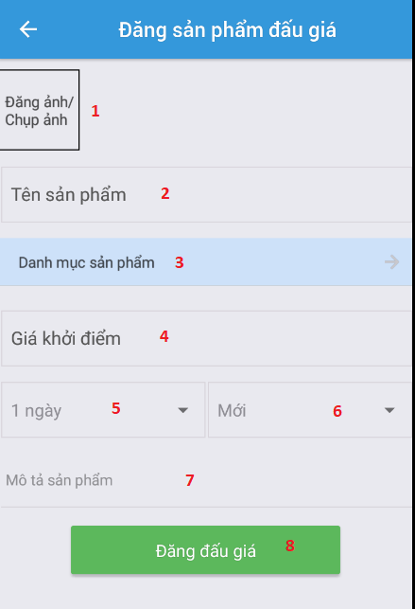

Figure 61 - Mobile Interface <Auction Submit>

**Field**

|  |  |  |  |  |  |  |  |
| --- | --- | --- | --- | --- | --- | --- | --- |
| **No** | **Field Name** | **Description** | **Read only** | **Mandatory** | **Control Type** | **Data Type** | **Length** |
| 2 | Item name | Item name to submit | No | Yes | Textbox | String |  |
| 4 | Reserve price | Auction’s reserve price to submit | No | Yes | Textbox | String |  |
| 5 | Duration | Auction’s duration to submit | No | Yes | Combobox | String |  |
| 6 | Item condition | Item’s condition | No | Yes | Combobox | String |  |
| 7 | Item description | Item’s description to post | No | Yes | Textarea | String |  |

**Buttons/Hyperlinks:**

|  |  |  |  |  |
| --- | --- | --- | --- | --- |
| **No** | **Function** | **Description** | **Validation** | **Outcome** |
| 1 | Upload images | Show popup to pick image or take a photo | N/A | Show popup to pick image or take a picture |
| 3 | Item’s category | Show popup for choosing item’s category | N/A | Show popup for choosing category |
| 8 | Submit auction | Submit auction to system | N/A | Show popup to confirm success |

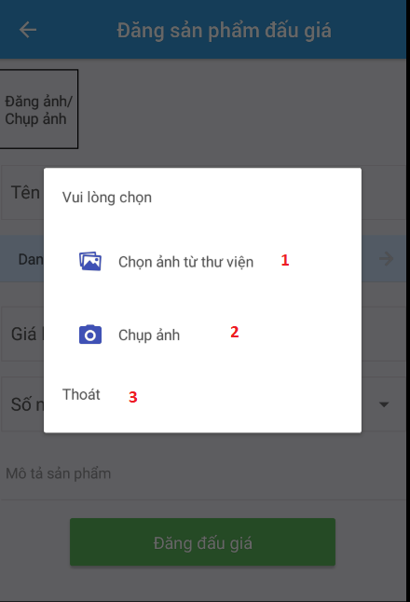

Figure 62 - Mobile Interface <Choose image>

**Buttons/Hyperlinks:**

|  |  |  |  |  |
| --- | --- | --- | --- | --- |
| **No** | **Function** | **Description** | **Validation** | **Outcome** |
| 1 | Pick image | Pick image from phone’s photo gallery, crop image if needed | N/A | Navigate to phone’s photo gallery to pick image |
| 2 | Take a photo | Show camera to take a photo | N/A | Open camera to take a photo |
| 3 | Exit | Close popup | N/A | Close popup |

#### Category page

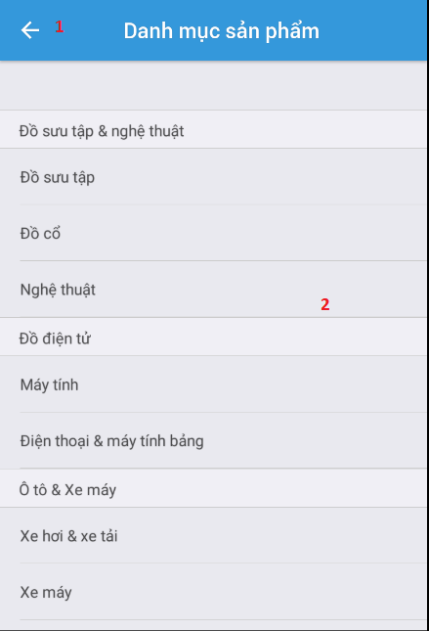

Figure 63 - Mobile Interface <Category>

**Buttons/Hyperlinks:**

|  |  |  |  |  |
| --- | --- | --- | --- | --- |
| **No** | **Function** | **Description** | **Validation** | **Outcome** |
| 1 | Back | Back to home page | N/A | Navigate to home page |
| 2 | Choose category | Show item by chosen category | N/A | Navigate to page that shows items by category |

#### Item By Category page

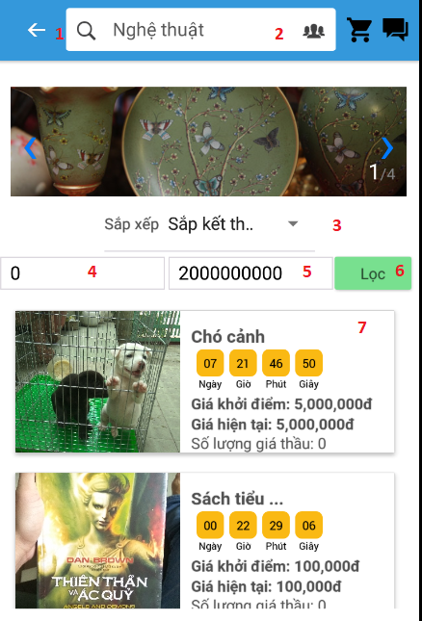

Figure 64 - Mobile Interface <Item by category>

**Field**

|  |  |  |  |  |  |  |  |
| --- | --- | --- | --- | --- | --- | --- | --- |
| **No** | **Field Name** | **Description** | **Read only** | **Mandatory** | **Control Type** | **Data Type** | **Length** |
| 4 | Min Price | Min price to filter | No | Yes | Textbox | String |  |
| 5 | Max Price | Max price to filter | No | Yes | Textbox | String |  |

**Buttons/Hyperlinks:**

|  |  |  |  |  |
| --- | --- | --- | --- | --- |
| **No** | **Function** | **Description** | **Validation** | **Outcome** |
| 1 | Back | Back previous page | N/A | Navigate to category page |
| 2 | Search bar | Show search page | N/A | Navigate to search page |
| 3 | Sort auctions | Show combobox to sort | N/A | Sort auctions by category |
| 6 | Filter auctions | Filter list by price | N/A | Update auctions with filter by price |
| 7 | View details | Show details of auction | N/A | Navigate to details of auction |

#### Search page

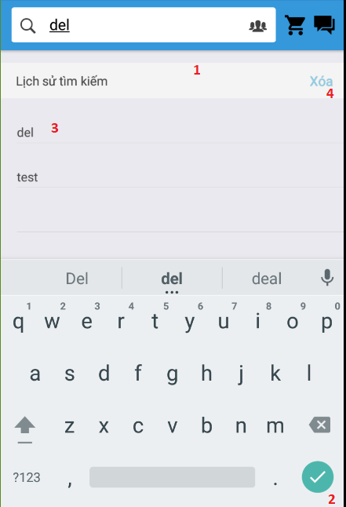

Figure 65 - Mobile Interface <Search>

**Field**

|  |  |  |  |  |  |  |  |
| --- | --- | --- | --- | --- | --- | --- | --- |
| **No** | **Field Name** | **Description** | **Read only** | **Mandatory** | **Control Type** | **Data Type** | **Length** |
| 1 | Search input | Keyword to search | No | Yes | Textbox | String |  |

**Buttons/Hyperlinks:**

|  |  |  |  |  |
| --- | --- | --- | --- | --- |
| **No** | **Function** | **Description** | **Validation** | **Outcome** |
| 2 | Search | Search item by keyword | N/A | Navigate to list item by keyword |
| 3 | Search | Search by old keyword | N/A | Navigate to list item by chosen old keyword |
| 4 | Delete history | Delete all history search | N/A | Clear list history keyword |

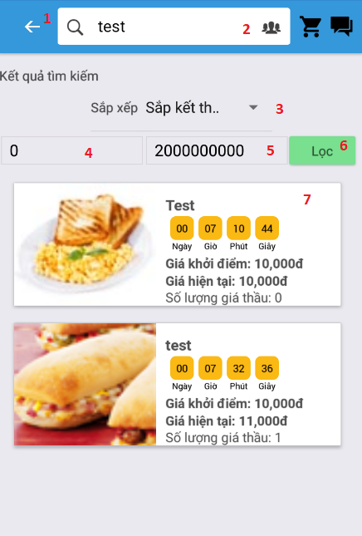

Figure 66 - Mobile Interface <Search result>

**Field**

|  |  |  |  |  |  |  |  |
| --- | --- | --- | --- | --- | --- | --- | --- |
| **No** | **Field Name** | **Description** | **Read only** | **Mandatory** | **Control Type** | **Data Type** | **Length** |
| 4 | Min Price | Min price to filter | No | Yes | Textbox | String |  |
| 5 | Max Price | Max price to filter | No | Yes | Textbox | String |  |

**Buttons/Hyperlinks:**

|  |  |  |  |  |
| --- | --- | --- | --- | --- |
| **No** | **Function** | **Description** | **Validation** | **Outcome** |
| 1 | Back | Back previous page | N/A | Navigate to category page |
| 2 | Search bar | Show search page | N/A | Navigate to search page |
| 3 | Sort auctions | Show combobox to sort | N/A | Show sorted list auctions |
| 6 | Filter | Filter list by price | N/A | Update list with filter by price |
| 7 | View details | Show details of auction | N/A | Navigate to details of auction |

## **Database Design**

### Entity relationship diagram (ERD)

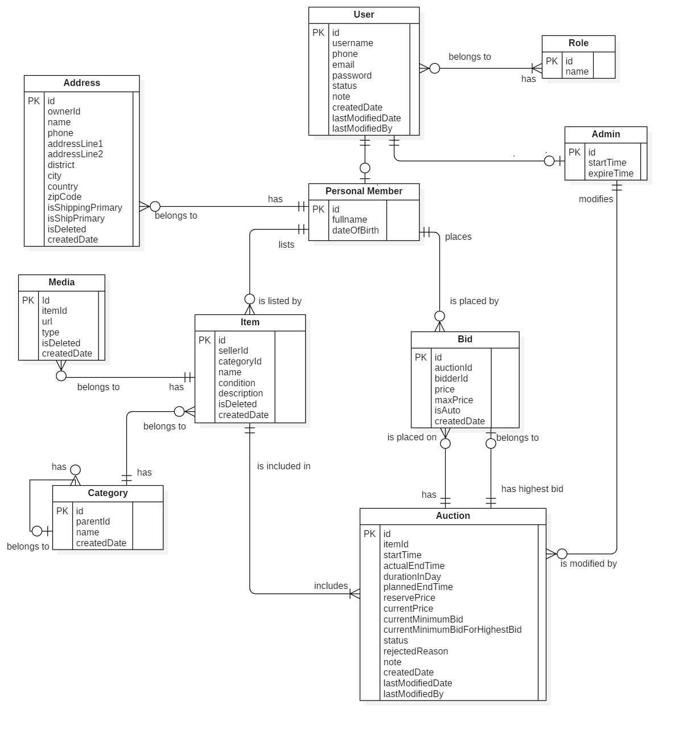

Figure 67 - Entity relationship diagram (ERD)

### Entity dictionary

|  |  |
| --- | --- |
| Entity Data Dictionary: describe content of all entities | |
| **Entity name** | **Description** |
| User | Contains the user information |
| Admin | Contains the admin information |
| Personal Member | Contains the personal member (auctioneer, bidder) information |
| Role | Contains the role information |
| UserRole | Contain the user’s roles information |
| Address | Contain the address roles information |
| Item | Contains the item information |
| Auction | Contains the auction information |
| Category | Contains the category information |
| Media | Contains the media information |
| Bid | Contains the bid information |
| MinIncrementRule | Contains the minimum increment rule information (for calculating minimum bid that bidder has to place on an item). |

Table 14 - Entity dictionary

## **Algorithms**

### Automatic bidding

#### Definition

Automatic bidding is a feature provided for the current highest bidder of an auction at a moment. User places the maximum bid at an auction that he/she is willing to pay for the item of the auction if he/she won. eBOS will automatically bid on the user’s behalf against other bidders.

#### Define problem

When a user bids on an item, he/she usually wants to pay less money for the item than amount she/she bid if he/she won. Another reason is that not every time the user is active at the auction to bid against other bidders to remain his/her winning chance. Therefore, we need to build automatic bidding algorithm in order to satisfy these users’ needs.

#### Solution

First, user has to place the maximum bid that the user is willing to pay for the item if the user won.

If the maximum bid is higher than the current highest bidder’s one, the user will become the new highest bidder. The maximum bid will be kept secretly from the seller and other bidders. eBOS will base on the maximum bid to bid on the user’s behalf against other bidders.

Otherwise, the maximum bid is accepted but eBOS will immediately bid on the current highest bidder’s behalf to outbid the user with amount that one *bid increment\** higher than the user’s maximum bid if it’s lower or same amount if it equals to current highest bidder’s one.

eBOS will keep bidding automatically on the current highest bidder’s behalf of an auction at the moment until current bid (item’s current price) reaches his/her maximum bid, he/she gets outbid by another bidder or auction ends.

*Bid increment*:* an amount will be added to the current bid (item’s current price) each time a bid is placed on the item. We call the result of the addition **current minimum bid** that bidders need to bid with same or higher amount next time.

Bid increment is calculated based on item’s current price:

|  |  |  |
| --- | --- | --- |
| **Minimum Price (VND)** | **Maximum Price (VND)** | **Increment (VND)** |
| 1,000 | 19,500 | 1,000 |
| 20,000 | 99,500 | 5,000 |
| 100,000 | 499,500 | 10,000 |
| 500,000 | 1,999,500 | 20,000 |
| 2,000,000 | 4,999,500 | 50,000 |
| 5,000,000 | 9,999,500 | 100,000 |
| 10,000,000 | 19,999,500 | 200,000 |
| 20,000,000 | 49,999,500 | 500,000 |
| 50,000,000 | 99,999,500 | 1,000,000 |
| 100,000,000 |  | 2,000,000 |

Table 15 - Bid Incremement

#### Complexity

The complexity of this algorithm is **O(1).**

#### Example

The following scenario demonstrates how the eBOS’s automatic bidding works:

Sơn, the seller, submits an auction with item whose name is Queen 1975 Album, with reverse price of 30,000 VND and a duration of 5 days. The auction is later accepted by admin in the same day.

**Day 1**: **Current price: 30,000 VND; Current minimum bid: 35,000 VND; Maximum bid: N/A.**

**Nam, views the auction, then decides to bid 200,000 VND. Since the auction has no one bidding at it, he becomes the highest bidder easily. The bid is registered with amount of 35,000 VND and eBOS remembers the maximum bid of 200,000 VND for automatic bidding. Item’s current price is raised up to 35,000 VND and current minimum bid required for next bid is 40,000 VND (current price + increment).**

**Day 2**: **Current price: 35,000 VND; Current minimum bid: 40,000 VND; Max: Nam - 200,000 VND**

**Minh views the auction and bids 40,000 VND. Because Minh maximum’s bid is lower than Nam’s, eBOS immediately bids 45,000 VND (Minh’s maximum bid + increment) on Nam’s behalf. Item’s current price and current minimum bid are raised in the same way as described in day 1.**

**Day 3**: **Current price: 45,000 VND; Current minimum bid: 50,000 VND; Max: Nam - 200,000 VND**

Minh decides to try again, he bids 50,000 VND which is still lower than Nam’s maximum bid. Because of that, eBOS immediately bids on Nam’s behalf. Item’s current price and current minimum bid is updated.

**Day 4**: **Current price: 50,000 VND; Current minimum bid: 55,000 VND; Max: Nam - 200,000 VND**

Minh decides to bid far higher than minimum bid with amount of 350,000 VND. This maximum bid is higher than Nam’s, so item’s current price is raised up to 200,000 VND (Nam's maximum bid) and current minimum bid is raised up to 210,000. Minh is now the highest bidder and eBOS is bidding automatically on his behalf.

**Day 5: Current price: 200,000 VND; Current minimum bid: 210,000 VND; Max: Minh - 350,000 VND**

During the final moments of the auction, a new bidder named Nga, bids amount of 220,000 VND. eBOS automatically bids on Minh's behalf, which outbids Nga with a bid whose amount is 230,000 VND. Item’s current price now is 230,000 VND and current minimum bid is 240,000 VND.

**When auction’s time runs out, Minh becomes winner of the item, now he is going to pay for it with price of 230,000 VND instead of his maximum bid - 350,000 VND.**

### Auction’s Time Remaining Consistency Among Clients

#### Define problem

Some of clients may have slow network connection, different or wrong system time of their devices with server’s, it may lead to an auction’s time remaining displayed wrongly or inconsistently on among client applications. Therefore, we need to solve the problem to bring clients better user experience.

#### Solution

Instead of letting client application calculates auction remaining time by itself, server will take the job, the remaining time is calculated as: **auction’s planned end time - current server’s time**.

When client application receives response which includes auction time remaining from server, it calculates **delay** from sending request to receiving response (plus delay for rendering view if needed), then it **subtracts auction’s time remaining from the delay** in order to get more accuracy time remaining.

#### Complexity

The complexity of this algorithm is **O(1).**

### Auction suggestion based on the one that user is currently viewing

#### Define problem

Users in eBOS might have same interests, behaviors, desires; this may lead users to visit or place bids at same auctions. We want to bring an exciting playground for every user with auctions or items that he/she may find them attractive, interested. Therefore, we took advantage of other users’ auction viewing history to find out users having same interest with the target user and suggest him/her auctions that most of them has visited besides the one that he/she is viewing currently.

#### Solution

Following steps are how we get appropriate suggested auctions for a user (**target user**) when he/she is viewing **target auction**:

**Step 1:** Get all records of viewing history whose auction’s status is active from database. We call the result **viewRecords.**

**Step 2:** Get number of unique users from viewRecords**.** We call the result **totalUserCount**.

**Step 3:** Get list of unique active auctions from viewRecords. We call the list **activeAuctions**.

**Step 4:** Loop through activeAuctions**.**

Each iteration, get currently iterated auction. We call the auction is **firstAuction**. We also get list of unique user viewing firstAuction (not including target user) from viewRecords and call it **firstUsers**.

Next, we loop through activeAuction inside the current iteration, starting from current iteration’s index. Each iteration, we get currently iterated auction, call it **secondAuction** and its list of viewing users (not including target user), **secondUsers**.

We get number of common users from firstUsers and secondUsers, call it **commonUserCount.** Affinity score for firstAuctions and secondAuctions is calculated as:

**Affinity score = commonUserCount / totalUserCount**

The affinity score between two unique auctions will be saved into a list at each iteration of inner loop.

**Step 5:** After finishing the outer loop from step 4, we sort the list of affinity scores in descending order; filter scores which is from target auction and another one and has positive value. From processed list of scores, we can get appropriate suggested auctions for target user.

#### Complexity

The complexity of this algorithm is **O($n^{2}$).**

#### Example

Nga, whose id is U006, is viewing auction’s information on eBOS website. The id of aution is A001, now we have to find 2 suggested auctions at maxmum having the highest affinity score with auction A001 for her.

Let’s assume that we have a table representing records of viewing history in database:

|  |  |
| --- | --- |
| **userId** | **auctionId** |
| U001 | A001 |
| U001 | A002 |
| U001 | A005 |
| U002 | A003 |
| U002 | A004 |
| U002 | A005 |
| U003 | A001 |
| U003 | A002 |
| U004 | A001 |
| U004 | A004 |
| U004 | A005 |
| U005 | A002 |
| U005 | A004 |
| U006 | A001 |

Table 16 - Example table for viewing history

After calculating as well as sorting, filtering affinity scores between auction A001 and other auctions, we have a table representing the result:

|  |  |  |
| --- | --- | --- |
| **First** | **Second** | **Score** |
| A001 | A002 | 2/5 = 0.4 |
| A001 | A005 | 2/5 = 0.4 |
| A001 | A003 | 1/5 = 0.2 |
| A001 | A004 | 1/5 = 0.2 |

Table 17 - Example table for affinity score

As we can see above table, suggested auctions we are going to recommend for Nga are ones whose id are A002, A005.